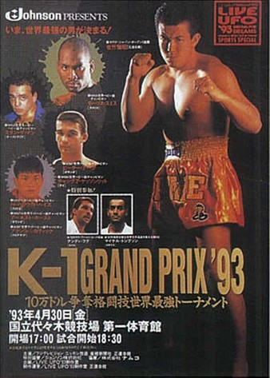
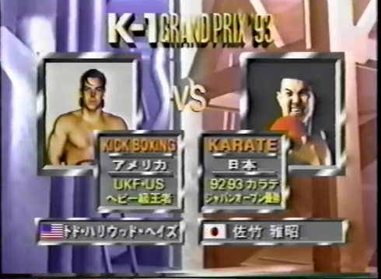
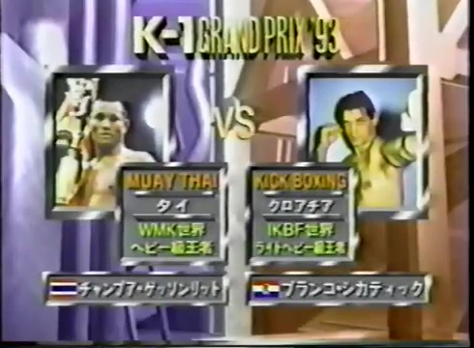
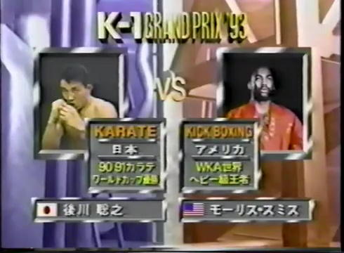
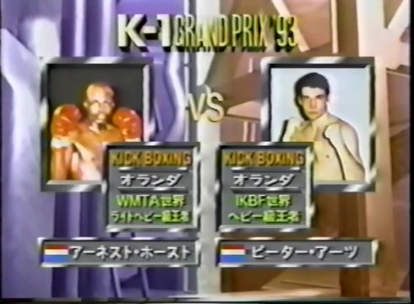
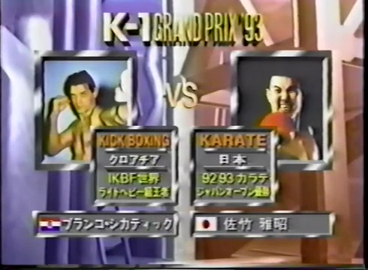
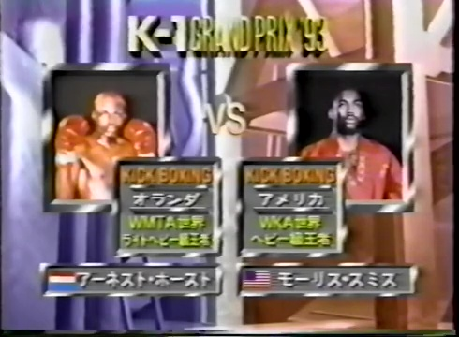
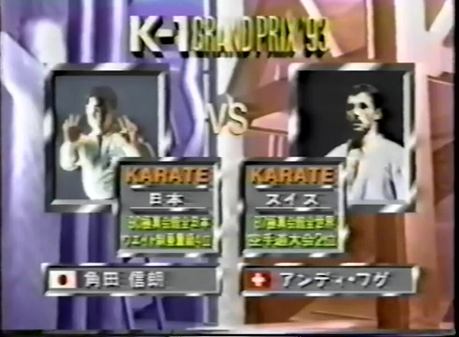
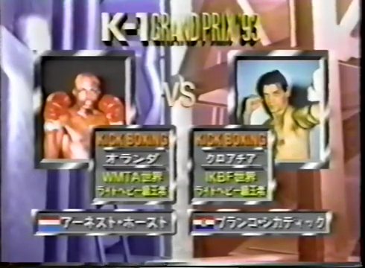
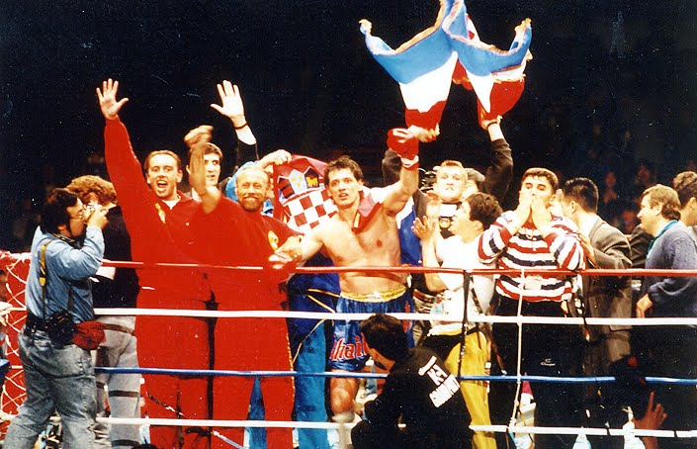
The date is 4-30-93, and out of the countless reviews and an untold number of words we have given the subject here at the Kakutogi Road, I believe that we have now officially arrived at a brave new world of martial arts pollination with the event we are about to uncover. Yes, this marks the inaugural World Grand Prix Tournament of the fledgling K-1 organization. No longer content to simply be another karate outfit, Kazuyoshi Ishii has been inspired by his friend and colleague, Akira Maeda, along with the spirit of Sogo Kakutogi (MMA), in an attempt to find who is the greatest fighter in the world. Granted, this event marks two important deviations for K-1, not only in the shedding of its Seido Kaikan karate skin, a mere martial arts discipline that hosted small insular karate tournaments, into that of a full-blown kickboxing league, but, perhaps most importantly, this marks the moment where Ishii began to distance himself from the RINGS vision of an international MMA federation into a hyper-focus on what is the best style of standing combat. The last several events from Ishii saw a confused flirtation into various types of mixed rules, which by a modern standpoint would seem to have been a hybrid of kickboxing and MMA fare, but at the time, they were experimental growth pangs in an effort to find their identity. From this point forward, Ishii would not give up completely on MMA, but throughout the rest of the 1990's it became regulated to an occasional hors d'oeuvre amidst the full-fledged footfighting on display. Also, we will no longer be witnessing RINGS being as much of an element within the K-1 brand. It looks like Ishii is wanting to carve out his own niche, his own vision, and while Maeda will continue to be both a friend and inspiration to Ishii’s model, the ship is now due to set sail on its own terms.
ML: A karate promotion was only going to go so far at the box office, and the art itself was becoming more of a niche among the many standup styles compared to it's 1960's and early 1970's heyday, so Ishii needed to do something bigger if he was going to promote more frequent events, especially on a larger and more high profile scale. He chose the style that was both more established worldwide, as well as much closer to what his fighters had been training, setting himself as a rival of the rather weak and clearly declining All Japan Kickboxing promotion (which Maurice Smith had often headlined for) rather than the growing RINGS promotion he was somewhat alied with.
Much like Bernard Marx before him, Satoru Sayama was the progenitor of this exciting new landscape. As Sayama was the only one vocally bucking the established pro wrestling apparatchik with his cries to discard the profane machinations of predetermined horseplay, so that one could make an effort to find their true potential in the unknown waters of shooting. Of course, this rebel with a cause found other Gotch-inspired kindred spirits within the genesis of the UWF in 1984, but this was only a shift in the right direction, a movement against the grain of a well ensconced puroresu establishment that feared significant changes. However, while that was necessary to get where we are today, the spirit of kakutogi is no longer a weird idea or fad, but it is now the de facto movement that all the momentum of the next 15 years will be gravitating towards. K-1, despite being heavily focused on kickboxing in the days and years ahead, will have an incalculable effect on MMA going forward. Not only will it see many of that new sports’ stars pass through, but its popularity will force the standing skill sets of many of the future players in MMA to develop their skills beyond what would have happened without their influence. Yes, the segregationist identity of combat sports is becoming more and more blurred and perhaps inclusive, with the advent of K-1 now being a major force, and we are all the better for it.
Masaaki Satake vs. Todd "Hollywood" Hays R2 0:45
This debut marks one of the more bizarre footnotes of MMA history, Todd “Hollywood” Hays. If anyone today remembers him at all, it was from his appearance in the Rickson Gracie documentary, Choke, where Dale “Apollo” Cook brought him along as an entrant into the Vale Tudo Japan 1995 tournament. His goal was to raise enough money to pursue his dream, which was Olympic bobsledding. What most people don’t know is that he got started here at the 1993 K-1 Grand Prix, presumably due to connections that Cook had with Ishii. It’s hard to imagine just how much training Hays had leading into this fight. He was a football player from Oklahoma that failed to get picked up by the Canadian Football League, but it’s a safe bet that he has a lot of athleticism, so this will be interesting to see how he fares against the man who Ishii is surely doing everything he can to make win, Masaaki Satake.
Round 1 begins, and Hays is looking better than I expected him to. While he is still a little raw and unpolished, he unquestionably has a lot of explosive power, and looks like he might be able to give Satake quite a challenge. Of course, there is no substitute for experience, and while Hays has power, he lacks crisp footwork, and his stiffness allows the more experienced Satake to finesse his way towards more successful output. As the round wore on, it seemed that Hays’ confidence waned more and more, until he was taking an excessive amount of unanswered leg damage from Satake.
It only took Satake 45 seconds to finish off Hays in round 2, making me wonder if Ishii did what he could to throw a rookie to Satake for an easy path forward into the semi-finals. On the bright side, Hays appears to be a fine physical specimen, and has a fantastic coach in Apollo Cook, but he wasn’t ready for a competition of this caliber this early in his career.
ML: Seemingly the big thing Ishii learned from Maeda was that a league can sell a large show on a big star, even if hardly anyone knows his opponent or the fighters on the undercard. Ishii had already been all in on Satake, his only true heavyweight, allowing the far more talented but older and smaller Nobuaki Kakuda to win if he could against whoever Maeda threw him in with, while Satake was given as many ridiculous mismatches as they could get away with when the outcomes weren't predetermined, and was often protected by the judges, or lack thereof, when they weren't. The brackets in this tournament were a joke, Satake got the worst first round opponent by far, while the two best fighters in the tournament, Hoost & Aerts, faced each other, of course in the bottom half. This bracket also contained Smith, probably down to being the third best fighter in the tournament due to his two losses to Aerts, meaning Satake presumably only had to get by 37-year-old Cikatic to get to the finals, as the supremely talented Changpuek was giving up probably 70+ pounds to these other guys. I think Satake just reaching the finals would be an acceptable result to Ishii, but if he could somehow get him through, it would be like finding the leprechaun's pot of gold at the end of the rainbow. Hays is the quicker and more athletic fighter, and clearly has potential. He gets off to a good start, but clearly has no answer for Satake's low kicks, and that quells all his aggression. Hays quickly became resigned to defeat, as his only answer to the low kick was to basically never commit to an attack, and just be ready to jump back when Satake threw, but even that didn't work half the time, and regardless he was getting none of his own offense off. Hays flopped early in the second from yet another kick to the thigh. This was very unsatisfying, as it just appeared Sakate walked over an guy who gave up because he wasn't properly trained.
Branco Cikatic vs. Changpuek Kiatsongrit R1 2:35
When we last saw Cikatic, the Croatian malcontent put forth a ho-hum fight against Stan “The Man” Longinidis, which he lost. Speaking of which, it’s a shame that Stan is not competing tonight as he has been on a tear lately winning over eight fights in a row since a split-decision loss to Maurice Smith back in 1991. Interestingly, this marks the K-1 debut of Kiatsongrit, a very game Thai fighter that always gave his opponent a tough job despite often being outweighed.
This bout already looks like a total mismatch from the outset, with Kiatsongrit being dwarfed by the Croatian sensation. To Changpuek’s credit, he stopped Cikatic’s initial onslaught with some nicely timed counterpunching, but it didn’t take long for Cikatic to flatline his much smaller foe. It wasn't that Kiatsongrit didn’t fight smart, he did, but he was easily swatted away whenever he tried to engage his clinch and simply couldn’t deal with the kind of rangy firepower that Cikatic had. It only took 2:45 for Cikatic to incapacitate Kiatsongrit with a left hook to the jaw.
ML: Kiatsongrit would likely have been the MAX champion had it existed in those days, but this match felt like if Buakaw fought Ben Saddik. Branco just has so much reach on Kiatsongrit that it was really difficult for Kiatsongrit to just make him work at all, much less force him into a mistake. Kiatsongrit was basically always out of punching range, and even with his speed advantage, he was essentially just throwing naked kicks, which weren't going to fool anyone from that far away. The first time Branco really landed, it was over.
Maurice Smith vs. Toshiyuki Atokawa 3R

This outing could be a make-or-break moment in the career of Smith, who won his last bout against Marcus Fuckner but lost to newcomer Peter Aerts before that. Smith is 32 years old here, so this may be one of his last moments to be able to go all the way in such a prestigious tournament. On the other hand, Atokawa's bad luck continues as he put up a most gallant effort last month when he faced Stan The Man, and now must face an even bigger opponent in Smith.
We got to see a very aggressive Maurice Smith in round one. To his credit, Atokawa held his ground and was able to fire off some nice counterpunching with Smith, but had a difficult time dealing with the tree trunks that were Maurice's legs. I wish we got to see more of this Maurice throughout his career, as he tended to be more passive in the opening round of his fights than what we saw here.
Round 2 saw some great stick'n'move from Atokawa. He routinely popped off some nice counters with his fists, but lacks enough firepower to seriously threaten Mo. This round may have been bad for Smith had he not been able to again depend on his extensive range advantage, especially with his kicks.
Smith seemed fed up in round 3 and unleashed a beating upon the nimble Atokawa until the inevitable decision victory. We have to give Atokawa a lot of credit, however, as the man has the heart of a lion. As much as I love open-weight tournaments in theory, I'll be happy when they give this man someone within his weight class.
ML: While Aerts may not have been a worldwide sensation yet, he'd been fighting since 1988, and already held at least 4 different titles, with two wins over Smith and two over Frank Lobman, who was an undefeated superstar coming off a title win over Bas Rutten when Aerts beat him the first time. Aerts size, and the angles that allowed him to use, presented an extremely difficult matchup for Smith, who never really found an answer, but little Atokawa presented none of the styistic difficulties that Aerts did. This was a more aggressive Smith, as he might normally be apt to look past such an opponent, but he had to worry about being in the best shape he possibly could for the semifinal given his next opponent was either going to be the guy he just lost to twice, or an even better fighter in his prime who he had yet to face. Atokawa is a game fighter that no one will ever accuse of not showing a ton of fighting spirit, but this was such a physical mismatch that it seemed like it would be a steady diet of Smith's right outside low kick and left body knee or liver kick. Atokawa made some good adjustments in the second, and was backing away then stepping forward with the body jab then getting out of range again. This became predictable though, and Smith wobbled him with a left straight counter. Smith had a knockdown with a right straight against the ropes early in the third, and the ref didn't get in there quick enough, so Smith got a big left hook in as well. The tough part about a tournament like this is you don't want to waste too much energy on a fight that you know you have won, but at the same time, the longer you are out there, the more chance there is that you will get injured yourself, and even though Smith isn't a big finisher, you know he had to feel like he should KO a fighter several weight classes beneath him. The third round was the most interesting because Smith did try for the finish, but this was the worst result for him because he used energy that he didn't need to, but didn't get the result he wanted. Considering how one sided the fight was, it was fairly entertaining because Atokawa was trying to win, and Smith was trying to finish.
Peter Aerts vs. Ernesto Hoost 3R
Now for the unstoppable force to meet the immovable object. This matchup is fascinating because on one hand, Aerts has been on fire lately, with wins over Maurice Smith, Adam Watt, and the legendary Frank Lobman. However, Ernesto Hoost has two prior wins against Aerts going into this fight despite not having the same overall momentum.
Round 1 was a fantastic conflict that was too close to call. Aerts is definitely the less fluid of the two, but made up for it at times with some hard shots that connected.
Aerts loosened up in round 2, and did a good job stalking Hoost down, which effectively negated some of Hoost's ability to fire off long-range combinations. Still, this was a very close round.
Both men came out with guns ablaze in a very close round 3. In a questionable decision, two of the three judges ruled it for Hoost, which may be accurate, but calling for an extra round seemed like a much more appropriate choice. This lackluster conclusion is especially dubious considering that they will seemingly give Satake an infinite number of extra rounds as the need arises. Good fight.
ML: While the first three matches looked like early prelims, this certainly looked like the main event it should have been. Aerts applied a ton of pressure, but wasn't able to go over or around Hoost's block the way he did against Smith. Hoost is a superior defender, and the much better and more fluid mover. Hoost was the more accurate fighter, but almost always was forced to defend before he could even think about going on offense. The first two rounds were basically even, so they both went all out in the 3rd. Hoost did his best to force himself to be offensive in this round, which helped because Aerts isn't as good a defender as he is. The problem wasn't Hoost being passive though, it's that Aerts would immediately start coming forward and firing the second Hoost finished his combo, so it was difficult for Hoost to avoid giving ground unless he wanted to eat punches to do so. This really depended upon what you liked. Hoost had more accuracy and defense, but Aerts had more attempts and aggression. This should have went an extra round. Hoost got the nod from the two judges that picked, but this was such a difficult high paced fight, it's hard to think this wasn't going to effect him going forward. Good match.
Masaaki Satake vs. Branco Cikatic R3 0:45
Here it is, the moment of reckoning we have all been waiting for. Up to this point, Masaaki Satake has been buoyed by a promoter all to happy to keep him propped up with corrupt judging and questionable opponents. However, one can only fake things for so long before they have to produce, and Satake’s true test lies before him.
Satake has always had a strong chin and an ability to take some punishment, but Cikatic is not the dude you want to stand and bang with. Wisely, Satake started calmly and only engaged Branco when he had to, to the point that the ref was getting agitated at the lack of fireworks. To the surprise of no one, Cikatic took a cheap shot to the back of Satake’s head while he was tangled in the ropes. Not that good behavior would have likely changed the outcome of this match, but that moment of cheatyfacing was the beginning of Satake's diminishing returns.
Satake did better in round two, in the sense that he was able to stave off the inevitable by continually tying up Branco in the clinch.
Satake decided to just stand and brawl with Branco on round 3, and it didn't take long for him to get flatlined for his trouble. Both Cikatic and Satake have similar styles of power-slop, so it is no surprise that a heavy-handed hitter like Branco got the better of each exchange.
ML: The great Japanese hope, Satake, fought this match without belief or confidence. It wasn't helping that he was losing every exchange, badly, to the point of getting his head bobbled or even knocked backwards. Cikatic may not be the greatest athlete or mover, but he knows he's not going to win through elegance, punching big and clean has always been his ticket to the top, and if you can't get him out of his game, he's going to run you over. Satake also wants to do a variation of that style by necessity, but he lacks the ability to force his offense or the fight ending power of Cikatic, so even in the better cases, he's mostly a guy who has to eat too many punches, and hopes his size can make up for it. Satake's ability to bully people has largely been based on fighting much smaller or barely experienced opponents (aka the handpicked barely trained mysterious foreigner of the month), which makes him seem more threatening than he actually . Cikatic is a true heavyweight though, and the larger of the two. He fought the way he always fights, and was very effective at it, while Satake fought scared, stalling as much as he could because that was his best defense from Branco's mighty fists. On the rare occassion Satake did try to attack, it went badly, with Satake constantly unable to avoid the big punch at the end of Cikatic's counter combo. Satake finally tried to fight in the 3rd rather than concede the decision, and while he got almost immediately KO'd for finally putting in the effort, it was definitely a less embarassing loss than most of what he was(n't) doing in the first two rounds. Another fight with little resistance put Cikatic in a much better position going into the final than either potential opponent is going to be in.
Maurice Smith vs. Ernesto Hoost R3 1:18
All of us here at Kakutogi HQ are cheering for Smith, as if the strength of our hopes and dreams will be enough to tear apart the spacetime continuum, thus forcing a rewrite of history.
Round 1 saw Smith do a very respectable job in taking on the role of the counterpuncher. The main problem here is that Hoost is a lot quicker than Smith, so Smith was never able to chain his attacks in a long succession.
Hoost immediately took Smith into some dangerous waters in round 2, pressing him up against the ropes for some prolonged damage. Smith never fully got his groove back in this round, opting instead to hedge his bets in the clinch. The problem is that Hoost is experienced in Muay Thai, and gave Smith plenty of knees for his efforts. Good round for Hoost.
Smith was flustered at the start of round 3, not seeming to know how to deal with Hoost. He basically threw the kitchen sink at Ernesto, but nothing was working, and it didn’t take long before he was put to sleep with a high kick to the jaw. The silver lining here is that this loss was the catalyst for a redirection of Smith’s career. Smith put pure kickboxing in the back seat to focus on Pancrase and RINGS before eventually winding up in the UFC, where he made history by proving that a kickboxer could be an MMA champion, beating a world-class wrestler no less. Smith’s kickboxing career was never quite the same after this. Of course, he went to return to K-1 after being infuriated at having to lose to Randy Coture’s boring lay-and-pray, but would never really be in the top echelon of their marquee fighters again.
ML: Though the shiny pants era of North American kickboxing that Smith was one of the dominant forces in clearly wasn't as evolved as their European or Japanese counterparts, which were much more influenced by muay thai than pro boxing, three of Hoost's 7 losses came to Jean-Yves Theriault (2) & recently Rick Roufus. The problem here isn't so much that Hoost comes from a better and more evolved background, it's simply that he has noticeably more power while also being quicker and more explosive. It's nice to be young. Smith can score as a counter puncher, but Hoost quickly proves that he will make him pay eating his lead leg up with the first shot. The problem is when Smith attacks, he can't lead nearly as big, and Hoost consistently uses his speed and reflex advantages to land back much heavier. It's kind of pick your poison. Do you want to take the kick to the same area and hope or try to be proactive and take the big punch to the face? Smith is used to fights where his conditioning and problem solving can help him take over as the fight progresses, his big 1991 win against Stan The Man was 12 rounds while his decision loss to Aerts was 9, but tonight he finds himself down two rounds in a three round fight after trying two different styles, which means he just has to make something happen in the 3rd. This match was much more competive than I'm making it sound, round 1 was pretty equal because Smith the counterpuncher was losing an attrition battle, whereas round 2 sees the proactive Smith getting hit with countershots that are just enough faster than what he normally sees that he usually can't quite avoid them. Smith had some success in both rounds, but he is very much a thinking fighter, and it had to be very frustrating when nothing he tried produced a pattern that he could actually exploit. Hoost's knockout wasn't from Smith being overzealous or anything, it was inside fighting and it looked like either fighter could have went for the clinch, but instead Hoost totally surprised Smith by bringing up the big high kick Smith didn't see. Overall, this was kind of a disappointing match given how great both fighters were. I mean, it's worth watching, but it always feels like Hoost is going to win one way or another, and that happens before it ever really catches fire.
Special Match – Karate: Nobuaki Kakuda vs. Andy Hug R2 1:26
It’s a shame that we didn’t get to see Andy Hug in the main tournament tonight, as he may very well have been able to add two Grand Prix wins to his impressive body of work. Hug is the best there is at what he does, even though what he does isn't very nice (Constantly ax-kicking other men with reckless abandon that is!). Kakuda, per usual, was completely outmatched, but fought valiantly especially with a great effort to turn Hug’s ribs into paste whenever they got into phone booth range. This match was tons of fun, and it was breathtaking watching Hug use crazy footwork to set up all kinds of crazy kicking attacks. Kakuda is a man without peer when it comes to heart, but sadly it only took a little past the 2nd round for Hug to obtain victory.
ML: It's amazing that future K-1 Grand Prix Champion Hug had yet to even compete in his first pro kickboxing match at the time this inaugural tournament took place. I really love Hug's footwork, and feel it's a huge reason he was able to have so much success with such a high risk, low percentage style. He is just so bouncy and springy all the time that it somewhat disguises the start of his kicks and spins. And that is what Hug does arguably better than anyone, just find a way to land big naked kicks, even axe kicks, which you basically never see anywhere else outside of women standing there and allowing Kumiko Maekawa to try to make it work. Despite the 5'11" Hug being one of the shortest fighters we have seen tonight, Kakuda still looks like he would be better served challenging Mascarita Sagrada for the Mini Estrella Championship. Kakuda knows exactly what he has to do, and does a good job of getting inside to land his piston body punches, the problem is he doesn't actually do much of anything to negate what Hug is trying to do before or after. Kakuda basically hopes that simply being close is going to be enough because Hug's techniques that are so much more explosive and punishing generally require distance, but Kakuda is the one who is predictable, and Hug can adjust, for instance finishing him with clinch knees in the 2nd. This was a fun fight, but not quite a recommendation given it was short and one-sided.
Final: Branco Cikatic vs. Ernesto Hoost R1 2:49
On paper this seems like a bad match for Cikatic. Hoost is younger, faster, and much more precise, but sometimes all you need is to have lead in your gloves, and that is one thing that Branco has outside of a bad temper and disregard for rules. Hoost spent most of the round performing well, chipping away at his older foe, until Cikatic charged in out of nowhere shortly before the round ended with a thunderous right hook that almost decapitated Hoost. This had to be the Croatian Sensation's proudest moment, perhaps outside of mentoring future kickboxing/MMA legend, Mirko Cro Cop. Cikatic would have a few more years of life left on the shelf after this, but this was his pinnacle.
ML: Ishii surely hoped that Satake could find a way through the super soft top half, and maybe the actual greats would have beat their bodies into oblivion by the time they made it here. Hoost definitely took the long hard road, defeating the two toughest fighters in the tournament in 5 1/2 rounds, while Cikatic only needed 3 1/2. I can't say that that was really the difference though, as Hoost simply didn't believe he could be the same fighter against the bigger and stronger Cikatic. He just had so much respect for Branco's power that he was hesitant, and Cikatic, while not being the most graceful fighter, does close distance a lot quicker than you might think. Hoost was feeling him out, making sure he defended as well as he could, and then would counter if it was there. Cikatic just layed him out with the counter punch to the counter punch though. This was one of the most impressive KO's I've seen in the sense that Hoost was literally so completely out at the moment of impact that he fell like a chopped tree, bouncing off the canvas.
Conclusion: While this may not quite be in the short list for most entertaining K-1 World Grand Prix events, it was still very worthwhile, and is mandatory viewing for any fan of combat-sport history. Thanks to this event, K-1 would skyrocket to the point where they were the most popular spectator event in Japan for a significant period of time, even eclipsing baseball, and Pride FC’s popularity. Their gravitatonal pull had an incalculable effect on the evolution of MMA from this point forward, as the cross pollination of various fighters shifting around between free-fighting and kickboxing would be the de facto state of being for at least the next 15 years. Thankfully, K-1 would sprinkle in a few MMA fights over the years until their recommitment to the concept in 2004 with their Romanex event, and subsequent Hero’s line of shows.
ML: This wasn't one of the great K-1 Grand Prix's, but especially given this was the 2nd true K-1 show, it's really amazing how many of the main players were already in place. In fact, it would take until Mark Hunt won the Grand Prix in 2001 (despite losing to Ray Sefo in the qualifying semifinal) for someone who didn't fight on this show to take home the trophy.
Krummel’s Korner
Of course, our most beloved translator, John Krummel, had plenty to dissect for this event. Let’s check in with him.
Narrator explains how this is a tournament that will decide the strongest fighter out of all the striking arts—karate, kickboxing, Kungfu, and so on, which the “K” of “K-1” stands for.

Opening ceremony: Narrator mentions how Maurice Smith is WKA’s top fighter; Peter Aerts from Holland; Masaaki Satake representing Japan. Satake, representing all the fighters, gives his ceremonial participants’ affirmation that they will fight fair with sportsmanship [this is a Japanese tradition in many sporting events].
Godzilla theme music. The Grand Prix winner gets 100,000 US dollars.
Held at National Yoyogi First Gymnasium
The announcer explains how this is a tournament to decide the best fighter among the striking arts (karate, kungfu, kickboxing, kenpo, etc., for which the “K” stands for). The winner wins 100,000 US dollars. He introduces Sadaharu Tanigawa, editor of Kakutogi Tsūshin [Combat Sports News] magazine as joining him as commentator. They talk about how this tournament has some of the top fighters from different striking combat sports. Tanigawa explains that since this is a 1-day tournament with so many top fighters, the key is for the fighter to win without receiving too much damage so he can fight in the next round of the tournament. When asked about who he thinks might win the tournament, he mentions Maurice Smith, the WKA world heavy wt. champion, but then also mentions Peter Aerts who had knocked out Smith recently in the Netherlands (Smith’s first KO loss), and in that sense Aerts is a favorite as well. [At this time, Aerts was unknown in Japan]. He’s also hoping Satake will do well too.
Announcer explains rules: 1st & 2nd rounds of tournament are 3mins 3 rounds; finals is 3mins 5 rounds. No elbows, no backhand blows. Also the knockouts come with 5 counts (rather than the usual 10 counts) except for the finals. [This 5 count rule seems a good idea for a one day kickboxing tournament]
K-1 GRAND PRIX '93 1st Round:
Masaaki Satake vs. Todd "Hollywood" Hays R2 0:45
Satake (Seidokaikan karate, Japan) is ’92 & ’93 Karate Japan Open winner; Hays (kickboxing, USA) is UKF (Universal Kickboxing Federation) US heavy wt. champion
The announcer mentions that Hays’ full-time job is a professional footballer; and he’s experienced in amateur boxing, in which he’s won a Golden Gloves title and was a candidate for the Olympic team. Dale Apollo Cook [who’s fought in Japan before, including the Kakutogi Olympic put on by Seidokaikan] is his coach.
Branco Cikatic vs. Changpuek Kiatsongrit R1 2:35
Kiatsongrit (muaythai, Thailand) is WMK world heavy wt. champion; Cikatic (kickboxing, Croatia by way of Chakuriki Dojo in Netherlands) is IKBF world light heavy wt. champion. This is Cikatic’s first time to fight in Japan. Kiatsongrit lacks opponents in Thailand because he’s too heavy there, and so has started fighting internationally. [The referee for this match is Genshū Igari, who was a legendary kickboxer from late 1970s to early 80s and I saw him fight on TV several times when I was growing up in Japan.]. Tanigawa says the weight difference (12 kilos difference) made a big difference here in the outcome. [Kiatsongri is heavy in Thailand, but still light compared to non-Thai fighters…]
Maurice Smith vs. Toshiyuki Atokawa 3R
Smith (kickboxing, USA) is WKA world heavy wt. champion; Atokawa (Seidokaikan karate, Japan) is ’90 & ’91 Karate World Cup winner. Atokawa is replacing Stan the Man from Australia who had to cancel his entry into the tournament. Smith, prior to receiving the two losses against Aerts, was for 8 years undefeated. He’s a favorite to win the tournament. Atokawa has a lot of potential.
Ernesto Hoost vs. Peter Aerts 3R
Hoost (Kickboxing, Netherlands) is WMTA world light heavy wt. champion; Aerts (Kickboxing, Dojo Chakuriki, Netherlands) is IKBF world heavy wt. champion. They’re both representing Netherlands but are from rival gyms. Aerts is only 22 years here. Hoost competes in various striking styles including muaythai and savate. This is Hoost’s first time in Japan [so not yet known in Japan]. [Interesting seconds: Gerald Gordeau in Hoost’s corner and Dick Vrij in Aerts’ corner]
K-1 GRAND PRIX '93 Semifinals:
Branco Cikatic vs. Masaaki Satake R3 0:45
They mention that Cikatic was the top fighter of Dojo Chakuriki before Aerts made his debut. He’s also a veteran of 54 fights.
Ernesto Hoost vs. Maurice Smith R3 1:18
Tanigawa mentions how in his magazine Kakutogi Tsūshin, they had a poll of readers who they think will win, and the top 3 were Aerts, Satake, and Smith… But Aerts and Satake are now out [and soon Smith is out too], surprising many of the Japanese fans [also I’d mention that Hoost and Cikatik, both strong fighters, were then unknown in Japan, fighting in Japan for the first time]. They also mentioned that Stan the Man is in Smith’s corner [though I didn’t notice it.] Stan the Man has only lost once in his professional career and that was against Smith, so he wants Smith to win probably.
Special Match - Karate: Nobuaki Kakuda vs. Andy Hug R2 1:26
Kakuda (Seidokaikan karate, Japan; 1990 4th place holder in Kyokushinkai All Japan karate championship heavy wt. division); Hug (former Kyokushinkai, now Seidokaikan karate, Switzerland; 1987 Kyokushinkai World karate championship 2nd place). The commentators mention after Hug wins that he will challenge the winner of the K-1 Grand Prix. They mention this will be a fight to look forward to. They also mention another karate match held that day but not televised of Taiei Kin vs. Michael Thompson [another ex-Kyokushinkai fighter who jumped to Seidokaikan karate] and Kin won by decision, surprising everyone. This was a big win for Kin against a top level fighter from Kyokushin.
Final: Branco Cikatic vs. Ernesto Hoost R1 2:49
Now for this finals match, the KO counts will be up to 10 instead of 5. The commentators mention that no one expected these two to make it to the finals [since they’re unknown in Japan]. But in fact, 4 years ago these two had fought in Europe, and at that time Hoost had won. Cikatic wins! He’s 34 years old. [This has got to be one of the pinnacles in fight history, when K-1 first started]
Krummel’s Korner: Supplemental
Our translator recently had to take a trip to Japan for some business dealings, so we won’t have our next Kayfabe translation until either the end of this month (December), or early next month, (January). In the meantime, here are some brief thoughts that he recently had to share with me on the topic of Sayama, and the UWF.
“One thing I wanted to tell you that I noticed recently on Japanese YouTube that I thought was interesting, as I came across comments and quotations of Sayama in some Japanese videos, that corroborate/agree with some of what Sayama says in those early chapters of Kayfabe I already translated: In Kayfabe, Sayama says how their training consisted mostly of shoot grappling/submission sparring sessions, and he was unsatisfied with the worked matches with the showy/entertainment elements, but that he believed at the time NJPW will eventually move towards becoming a real sport with shoots. In the quotations on the YouTube videos, Sayama says how, in his conversations with Inoki from those early days, Inoki would tell him that in the future they will have two divisions within NJPW, a worked (prowrestling) division and a shoot (real fight) division; and that he (Sayama) will be the first fighter in the shoot division. This was years before Tiger Mask when Sayama was still an undercard wrestler and Inoki’s “young boy” personal assistant. So, it makes sense that Sayama was very disappointed when they sent him to Mexico to learn lucha libre ,and then after his stint in England as Sammy Lee, made him into Tiger Mask.
Eventually Sayama retires from pro wrestling, UWF starts and he forms Shooting in the mid-80s, and finally UFC appears, and MMA starts in Japan in the 90s. It makes sense then that at the end of the 90s, Inoki tries to move NJPW into the direction of MMA/shoots when he pressured a number of NJPW wrestlers—Nagata, Fujita, Kendo Kashin, Yasuda, Nakanishi, Shibata, and others, etc.—to fight in Pride, and then also had some shoots or semi-shoots in NJPW itself with the Ultimate Crush event, NJPW vs K-1 event, etc.. Eventually as this led to promotional disasters in NJPW, Inoki was pressured to quit NJPW, so he starts UFO with Ogawa as the star, and after that folds, he starts IGF, “MMA” promotions that were more toward the early RINGS formula , an international conglomerate of mostly worked shoots featuring fighters with real combat sports backgrounds. When I think of what Inoki told Sayama when Sayama was still an undercard wrestler, all this now makes sense as that was what Inoki had envisioned back then long before people even knew about MMA in Japan. People like Choshu, Sakaguchi, Mutoh (Great Muta), were completely opposed to this in NJPW, and criticized Inoki’s vision, wanting to keep prowrestling an entertainment. NJPW now is much like WWE with overly-worked works. But I kind of miss that mixing of prowrestling and shoots. I miss UWF style along with that style of prowrestling Inoki envisioned , and promotions like UFO/IGF that had both is understandable.
*In Other News*
Yoshiaki Fujiwara recently announced that he will be bringing the PWFG (which has been inactive for most of the year) back in June, and that his first show will be in tribute to his departed friend, Masami Soronaka.

