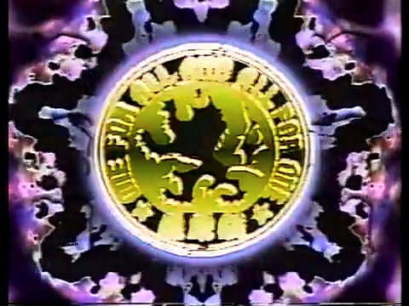
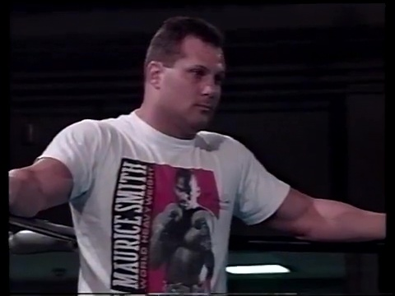
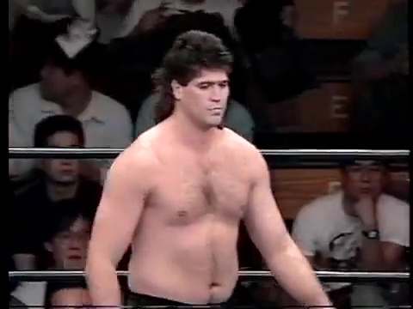
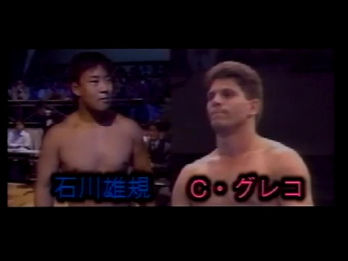
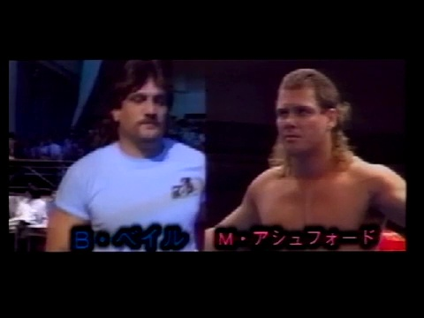
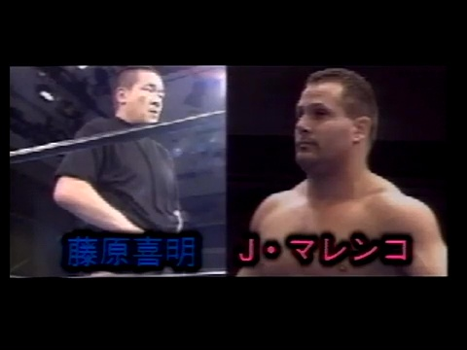
Socrates is famously attributed with the axiom, "The unexamined life isn't worth living." However, in light of where we are in this blood-spattered era of history, it may be better to say that the unlived life isn't worth examining. Indeed, painful rumination was at the forefront of Yoshiaki Fujiwara's mind as he was headed to the gallows in the middle of 1993. With all his financial backing and significant talent abandoning him, one couldn't have blamed him if he had just given up and accepted his cruel fate. In fact, for most of 1993, this appeared to be the case, as Fujiwara was willing to let his remaining roster find work where they could get it (in this case, Akira Maeda's RINGS promotion), all while Fujiwara scooped up a couple of quick paydays with NJPW.
While it had to have been comforting knowing that he could always fall back on a quick paycheck, the humiliation of having packed out the Tokyo Dome only eight months before now, and having to restart in the quaint confines of the Korakuen Hall, had to be quite the mental toll. After all, wouldn't it be natural to second guess how you went from being a significant player in the kakutogi-wars to being on the verge of insolvency in months? Perhaps, it was Fujiwara's shortsightedness as his main stars, Funaki, Suzuki, and Shamrock, had all been trying to push the envelope into going toward more real shoots. By the end of 1992, Fujiwara seemed willing to acquiesce slightly by allowing the occasional shoot. Still, one could clearly see that he wasn't comfortable with committing wholeheartedly to the concept. Being killed amid a battle against your rivals is honorable, but no one can bear being mortally wounded by their own inflexibility.
This was the story when market forces were set to sweep Fujiwara’s vanity promotion into the aether when at the last minute, Fujiwara decided that he still had some fight left in him. Time will tell if this was a courageous act of defiance or a miserable attempt at delaying the inevitable. Either way, Fujiwara and his PWFG have received a stay of execution, a respite from the impending doom thrust upon them.
ML: Fujiwara was always going back to Korakuen Hall. The problem is now he has no escape. Lacking a roster, all Fujiwara can do going forward, or at least until he finds new recruits, is take the path of Akira Maeda and try to find someone with enough notoriety that people will show up for the main event, regardless of whatever rookies or hasbeens he can unearth to fill out the card. The problem with this though is that, unlike Maeda, Fujiwara wasn't really the focal point of his promotion, and now that he's had to return to NJPW, he's had to accept the role of just another midcarder.
The date is 6-1-93, and we are only three days removed from PWFG's top rookie, Ishikawa, having a 30 minute draw in RINGS. We are first treated to a montage of Fujiwara drilling what's left of his roster. Based on the footage, it's easy to see that Fujiwara would be an excellent choice for a takedown symposium, although watching him try and demonstrate striking techniques is genuinely cringe. The best part of this was seeing Joe Malenko sport a Maurice Smith t-shirt while training, which made me mad that I don't have one.
ML: Fujiwara's group was on a better trajectory before the tragic passing of Masami “Sammy” “Mr.” Soranaka due to a brain tumor on 6/11/92. Soranaka did a little bit of everything in the combat sports world. He was a referee for New Japan starting in the late 1970's and the original UWF when it started, then a wrestler for UWF, then after he moved to Florida a trainer with the Malenko wrestling school focusing on shoot wrestlers that would be sent to UWF, a booker for PWFG, and the president of the International Shootfighting Association. His fighting background was well rounded with judo, karate, and even sumo, where he was surely wildly undersized. He was around pro wrestling all his adult life, as his brother, Hiro Sasaki, was a wrestler based out of Hawaii who was NJPW's liaison for the territory, and his father in law was the legendary Karl Gotch. Soronaka was a very good athlete, and seemed a natural all around in ring talent when he became the 1st graduate of the UWF dojo. The only problem was that he was already in his 40's when he debuted, and they obviously didn't last long due to the internal strife, ending his career before it really got going. As almost all the native talent has left Fujiwara, as well as the most important fighter Soranaka trained, Ken Shamrock, tonight's tribute show largely consists of the Florida contingent.
Everyone needs a Mo’ Smith shirt.
10 Minute Exhibition Match: Yoshiaki Fujiwara vs. Shinobu Kandori 10:00
The first match has yet to happen, and we can already see that this isn't your dad's PWFG. This event starts with an unusual gimmick exhibition of Fujiwara facing off against LLPW's Shinobu Kandori. To be fair, we all wish we could have seen this sort of thing when Ronda Rousey was going around saying she could beat Overeem in a no-rules fight. This exhibition is strangely groundbreaking since it predated the spectacle of Lucia Rijker losing to a male Muay Thai fighter by about a year.
This appeared to be a real example of a submission grappling exhibition and was a total embarrassment for Kandori. She looks like she has the skills to completely tool her female colleagues but can't buy a submission against the ancient Gotch disciple. This isn't really the kind of thing you can give a rating to, but I recommend it on the unusual novelty alone.
ML: Fujiwara gave Kandori a lesson in humility 101 in this jokey exhibition neither were taking too seriously, though moreso Fujiwara. Fujiwara had a huge advantage in height, weight, and leverage obviously, so he'd usually wind up on top, and they'd tap at anything even remotely reminiscent of a submission, so that put Kandori at a huge disadvantage. He mostly just let her attack him then countered with a submission. Kandori tapped more times in 10 minutes than in the rest of her career combined. Fujiwara made a joke or two and kissed Kandori at one point, since apparently even a shoot mixed match has to have pervy sexual abuse.
Jerry Flynn vs. Dieuseul Berto 14:22
It's been about six months since we've seen Flynn, who entered the shoot-style game strong in 91', but was starting to phone it in towards the end of 92. On the other hand, Berto seems like a rookie with good potential, but this hiatus has probably hurt him more than anyone else on the regular roster.
This match followed the tone of the opener by feeling like a friendly striking exhibition. It was alright, especially since Flynn was stiffer than usual, but Berto's lack of ground finesse held back the momentum that this could have achieved. The best part of this had to be the overeager referee who would shout out the 10-count as loud as possible, all while wagging his finger in the face of the downed fighter. ** ½
ML: Shoot fighting isn't a style that provides the leisure of being leisurely. These two fought a passable fight, but in trying to build the intensity after a very flat opening, they had already lost me well before it got somewhat interesting. The main thing to recommend here was some stiff strikes by Flynn. Berto was passable, but showed no particular energy or enthusiasm, which made the portions where he was on offense somewhat dull. Eventually, it just kind of ended without ever taking off or Flynn being in any real trouble. I was much higher on Flynn when he started. This opposition wasn't helping much obviously, but anymore it always feels like Flynn never really puts it together.
Yuki Ishikawa vs. Carl Greco 19:59
This matchup is interesting as it marks the debut of Carl Greco, who would not only be a fixture in the shoot-style world within the Battlarts moniker, but would later go on to fight in Pride FC, where he scored an impressive win over Egan Inoue. Also, it was only three nights ago that Ishikawa gave us the best match of the evening during his crossover appearance at Fighting Network RINGS. Speaking of Ishikawa, it is remarkable how much his demeanor has changed since the mass exodus of Fujiwara's top-shelf talent. Whereas he looked meek before, just finding his place in the landscape, now he is strutting around like a bonafide star, knowing that he is now becoming the de facto face of the promotion. This contest started excellently, where Greco's athleticism brought out Ishikawa's best. Ishikawa's main drawback thus far has been his tendency to slog through his works, but here he was forced to keep up a crisp tempo with Greco. This also had a good blend of strikes and submission attempts. Watching this did aggravate me when I realized that having these two on the roster in 1991 would have been a game changer, as opposed to all the times we had to slog through the likes of Johnny Barrett, Wellington Wilkins, and Lato Kiraware. Still, despite these both being fine talents, neither has the charisma that Fujiwara needs to pull himself out of the quicksand he has found himself in. Bonus points for Greco working several techniques we haven't seen before, including an inverted triangle and some nifty work from half-guard. This was longer than needed but a fine showing, nonetheless. *** ¼
ML: Ishikawa was the only fighter not to abandon Fujiwara's ship, and is now fighting with more confidence as the #2 native in PWFG, by virtue of there only being 2! Greco, the stepbrother of Joe & Dean Malenko, was taken in off the streets by Boris Malenko, and became one of his best students. This was his pro debut, but he already seemed deserving of the Bello Greco moniker that was made famous by the father of Super Calo and Alan Stone in the 1970s, though not in the exotico kind of way. Greco is an excellent athlete whose movement is incredibly fluid, especially for someone so inexperienced. This match was loaded with nice transitions, counters, and scrambles, with Greco often seeming a step or two ahead on the mat of most of the experienced natives Ishikawa has been fighting, and arguably even Ishikawa himself. Greco was pushing the pace, and often it was actually Ishikawa that had to keep up with him. Don't get me wrong, Ishikawa is really coming into his own this year. He has been on a role, and was quite impressive here too. These two just react to one another and compliment each other so well that it was a lot of fun seeing what answers they'd come up with. I like this more on his toes the version of Ishikawa that Greco was pulling out by countering rather than disengaging. Ishikawa was clearly the better takedown artist of the two, and thus would start with the advantage most of the time, but Greco often countered quickly once they hit the mat. Greco was also able to go into a submission off to takedown, for instance, when Ishikawa hit the single leg, Greco stepped over into an armbar attempt. Ultimately, this looked like a Tamura match. The action was consistently impressive, with ever flowing matwork, as they just kept moving and threatening each other on the canvas. Overall, I was super impressed with both fighters and the match itself. It wasn't the most heated contest you will ever see, even feeling a bit of a grappling exhibition at times, but it just never slowed down. It was not only better than ishikawa's very good 30 minute draw against Naruse on May 29th, but actually one of the best shoot style matches we've seen thusfar in 1993. ***3/4
Mark Ashford vs. Bart Vale 10:07
Let me tell you a story about the time when Bart Vale kicked a man just to watch him die. Here we had a very unusual occurrence: Bart Vale took this seriously and was working with some stiffness and urgency and nearly killed his opponent with a terrifyingly nasty jumping kick. Bart still moved with a Dolman-like crawl while on the mat, but you could tell that, by his standards, this was a genuine effort. It’s a shame that it almost took a man being decapitated to make a Vale match enjoyable, but here we are. I award this a sadistic ***
ML: Normally, the only thing worse than one American in a match is two Americans in a match. This was shockingly decent, though. It was far from a good or consistent match to be certain, but at least it actually had some highlights, which made it an all-time classic by Vale's not so lofty standards. Vale never put much emphasis on the tudo, but Smith did a few pretty nifty things on the mat, including the counter I've been waiting forever to see. When Vale had a lame standing half crab that was putting no real pressure on, Smith just snuck back through the legs, but then Vale dropped into an armbar attempt. It would have been cooler if Smith would have been able to attack some sort of leglock from here, but Smith was basically just a jobber here, which I suppose was the story of his career, unfortunately. Vale wasn't being such a creampuff here, actually throwing with some real impact, including impressive switch high kicks. The first worked so well in nearly killing poor Smith that Vale went back to it after a cool combo where he threw a left palm to the head and a right palm to the midsection almost simultaneously. Vale then followed with a series of more good kicks than he's thrown in his entire career combined for the KO.
Yoshiaki Fujiwara vs. Joe Malenko 21:32
Well, Fujiwara couldn’t leave well enough alone, as he managed to put on an interesting and highly unusual opening exhibition only to insist on dragging this card down with an overlong outing where he refuses to put a young buck over any more than he has to. The Fujiwara of 1984 would have made this paring must-see TV, but as it stands, this was serviceable, but far too long. Make no mistake, Malenko is fantastic and moves around wonderfully; the problem here is that he is basically a younger, fitter, and more juiced-up version of Fujiwara, which makes it completely hokey that Yoshiaki can even last five minutes in this context. At this stage, Fujiwara needs someone that is a sharp contrast, like a Don Nielsen or another scrappy kickboxer/striker, as that would allow the mystique of ancient grappling wisdom against modern footfighting warfare to be the focal point. This wasn’t bad as it was incredulous, especially seeing poor Malenko lose to a straight-armbar. **
ML: Fujiwara has reached the point where his roster is so thin he needs to work twice in a night in order to sell tickets. JWP always had this problem in the 1990s, but there you had a mid-20s Mayumi Ozaki, who might manage to have two good or better matches in the same night. Fujiwara wasn't nearly that energetic, and that was the big problem with this main event. Malenko looked very good early on, moving quickly and showing impressive balance, but he wasn't really able to play off his stationary opponent very much, and thus the match eventually stalled out and just crawled along to the finish. Fujiwara wasn't bad at the outset, but Fujiwara basically needs to be fiery and sadistic to be interesting, and he was never either. It's unfortunate because Malenko was a reasonable and good opponent for him, an established older mat oriented fighter that Fujiwara wasn't too many decades older than. Actually, there was only 7 years between the two, but the way the two moved and the energy they showed, the age gap certainly appeared to be as large as it looked. Malenko looked better and more prepared than he did in his match against Minoru Suzuki, but that's partly because Fujiwara wasn't putting up much resistance, while Suzuki was constantly trying to be a step ahead of Malenko to thwart him. Most of the highlights came early on, as Joe was really pressing the action. As the match dragged on and on, Fujiwara was really gassed and could only offer small intricate details. Malenko had little reason to continue his fluid movement because Fujiwara wasn't countering, or doing enough to keep Malenko providing the action. Finally, Fujiwara countered Malenko's front facelock with the slowest wakigatame ever to end the match out of nowhere. This was ten minutes too long for Fujiwara, and wound up being the worst of the four real matches on the card, which was disappointing given Joe did good things there, and seemed more than capable of doing something much more consistently interesting.
Conclusion: This was much better than I expected it to be, especially considering the lack of heavy firepower that Fujiwara has left. Greco is a great addition and could be rookie of the year if he maintains his quality output, but sadly things are not looking good in terms of the overall picture. If Fujiwara wishes to continue down the road of deep Socratic introspection, he must ask himself, “What’s my reason for existence?” Where does the PWFG now stand in the current kakutogi tapestry? It can’t hope to be as entertaining as the UWF-I, nor does it have the resources of RINGS, so where do you go from here. One must wonder if Fujiwara was in deep shame and regret for not allowing the inmates to run the asylum and permit more shooting shenanigans from his rebels with a cause. Therein lies what was probably at the heart of Fujiwara’s problem. I am only now starting to understand that when your motivation is vanity over ideology, that makes you incredibly vulnerable. Funaki had a vision, even if he didn’t fully understand it yet. “Real” pro wrestling was clearly burning within him, and he needed to break new ground to see that as an outlet, not just a means to get himself over every month. Funaki had a dream that was bigger than himself, whereas Fujiwara was the lynchpin in his small world. Likewise, Maeda seems to understand that there is more in the atmosphere than the status quo thus far. Even though he realizes he must carry the promotion on his back with worked main events, you can tell there is a genuine desire to push shooting as far as he thinks he can get away with it. Still, despite his treading a line of ambiguity, Fujiwara should be proud tonight. Despite the lack of star power, he put on an entertaining card and is excellently mentoring Ishikawa. This stay of execution showed that Fujiwara could still put out respectable output. Still, the days are coming when either through lack of funds or desire, the PWFG will be reduced to treading water with a plethora of comedy matches, co-promotions with less serious leagues, and very little in the way of a stable roster. This may be the last full column that we dedicate to this group, but rest assured that we will continue to monitor everything that goes on with them and report any/all of the highlights to you all.
ML: Ishikawa and Greco are going to be worth watching, and there's a few rookies set to debut this year, including Daisuke Ikeda & Shoichi Funaki, but Don Arakawa will also be appearing soon, which tells you all you need to know about the seriousness of this promotion. They may still be able to muster something interesting on the undercard, but they obviously don't have the talent to put on top to bottom shows the way UWF-I can when they want to. Fujiwara seems to be a man out of time, but fear not, he still has 30+ years left in his career.
Krummel’s Korner
Let’s check out what our esteemed translator, John Krummel, had to say about this event.
PWFG Reborn Fujiwara Gumi Debut 1st Battle Submission Hell Classroom 6-1-93
Held at Korakuen Hall, Tokyo.
[They open with training scenes. It was cool to see Malenko wearing a Maurice Smith T-shirt.]
The Japanese title also states it’s a memorial event for Soranaka (the UWF & PWFG referee, Karl Gotch’s son-in-law, deceased 1 year).
Interview with Ishikawa: “My hopes? I would like to challenge myself in all sorts of ways, by taking hold of all chances given to me and the chances I make for myself. Whether I succeed or fail, I’ll get something out of that. I’ll work hard…. The Fujiwara-gumi has again started to tread a new path to unfold a new history. Please continue cheering for us.”
Interview with Fujiwara: “Yeah, to be honest with you, I thought the show in January was going to be our last show. But, somehow, we survived up to this point. I’m very thankful of this fact. Thank you for supporting and cheering Fujiwara-gumi. We’ll continue working as hard as we can.”
Opening ceremony:
10 count for Mr. Soronaka, referee who passed away last year in Florida. The ring announcer tells the audience to stand.
The announcer reads a message from Karl Gotch: “I feel much regret that I cannot travel to Japan for this very important event commemorating the passing of my son-in-law Soranaka, and that would mark a new start for Fujiwara-gumi. Fujiwara, you must have learned a lot from this recent debacle, and now you face a road of difficulties. But do not forget there are many people cheering for you and supporting you and who long to see the warrior in you. Even though you and I are separated by the distance as far as Florida and Japan, don’t forget that I will always support you and am cheering for you. Your old friend, Karl Gotch.”
Opening speech by Yoshiaki Fujiwara: “Thank you for coming tonight. We have finally been able to return to Korakuen Hall. This was due to all of your great support. Thank you very much!”
Ishikawa’s speech: “Thank you for coming tonight. Today Fujiwara-gumi will re-start. Together with our boss we all intend to keep the banner up. Please cheer for us!”
[By “debacle,” I understand they’re referring to Funaki, Suzuki, Shamrock, and several others leaving PWFG to form Pancrase…]
10 Minute Exhibition Match: Yoshiaki Fujiwara vs. Shinobu Kandori (Ladies Legend ProWrestling)
[Interesting since Kandori won the bronze medal at the 1984 World Judo Championships and then became a prowrestler and she’s been known to be a real shooter. There’s a famous match which can be found on Youtube where a young and not yet so known Kandori double-crossed the famous 70s superstar Jackie Sato, shooting on her to win the match. This match with Fujiwara looked like a real grappling sparring session that they might have in the dojo; it was interesting. Nevertheless, Fujiwara is not only the stronger and heavier sex, but also the submission master. It’s interesting how in a prowrestling show, they call the shoot match an “exhibition.” It looked like they were having fun. And they showed much respect for each other. I think it would also feel awkward to grapple with the opposite sex, making it difficult. ]
30mins 1 fall: Jerry Flynn vs. Dieuseul Berto.
[Both Berto and Flynn will later go on to fight in MMA in the US, but without much success, unfortunately.]
30mins 1 fall: Yuki Ishikawa vs. Carl Greco.
30 mins 1 fall: Mark Ashford vs. Bart Vale. [battle of the mullets. Ashford tends to over-sell when being kicked by Vale… it looks too much like a traditional prowrestling selling and looks unrealistic. I’m also surprised to learn that later he’ll appear in Rings… he seems better off in traditional American style prowrestling.]
30 mins 1 fall: Yoshiaki Fujiwara vs. Joe Malenko [Great to see any of the Malenkos in a UWF style wrestling match… The ending: I can’t figure out how Fujiwara made that switch in the end from being hooked in the neck/face to hooking Malenko’s arm/shoulder… the camera focus/angle was too close. I know it’s a work, but the close-up made it difficult to see. It looked like Malenko just let go of the neck lock in the end to let Fujiwara make the switch… which made it a little unconvincing. Nonetheless, a good scientific submission wrestling match.]
*In Other News*
Recently we reported that Stan “The Man” Longinidis defeated Dennis Alexio last December with a brutal kick that fractured Alexio’s leg. This led to Stan winning the coveted ISKA World Heavyweight Championship, but the plot has thickened because Alexio’s management is demanding that it be ruled as a “no-contest.” The rationale is that after Stan’s kick, Alexio stepped on an irregularity on the mat’s surface, which allegedly prompted the injury. As of press time we are still waiting for the results of ISKA’s five-member council, which must rule on the fate of both Alexio and the title. Apparently, the confusion is due to conflicting reports from the ringside doctor who at first stated that Alexio’s injury happened before Stan’s kick but is now changing his assessment to say that the kick did, in fact, cause Alexio to slip and break his leg. Stay tuned.

