
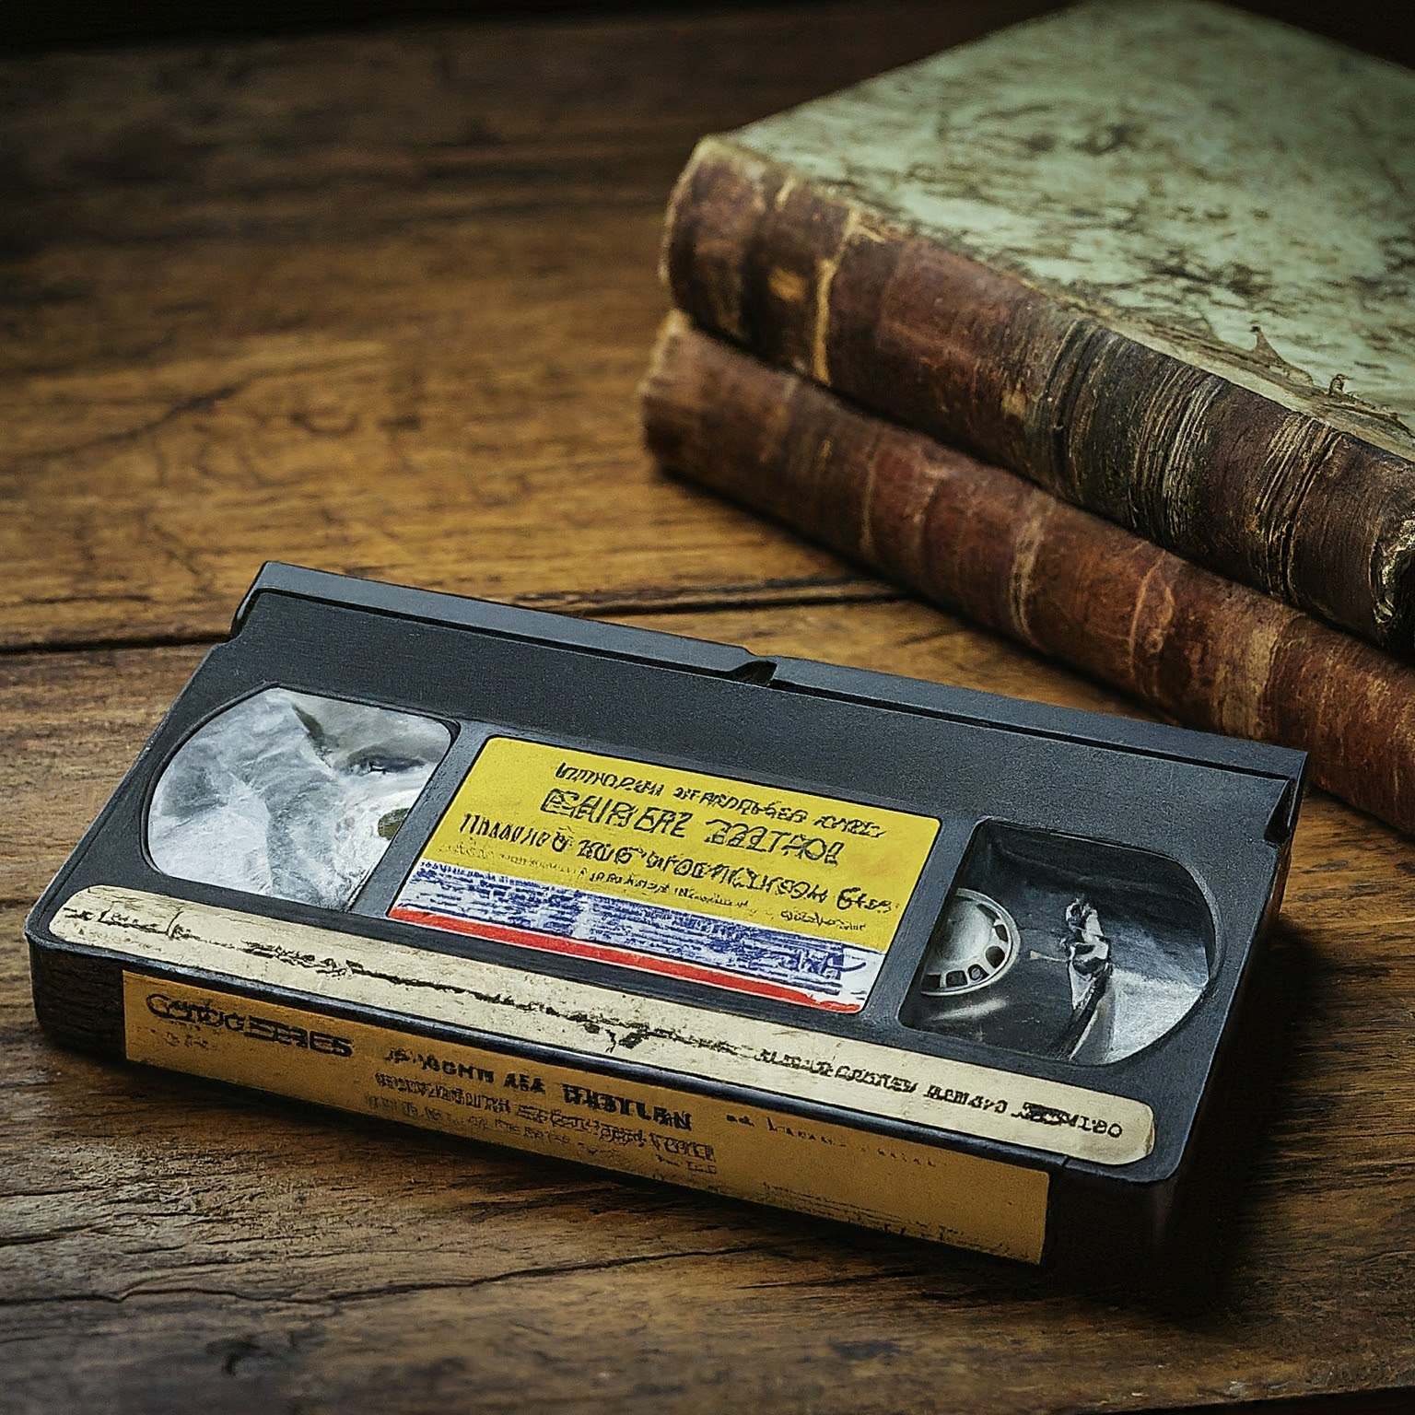
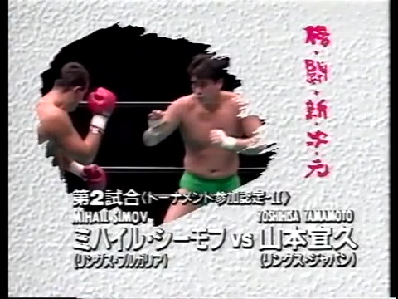
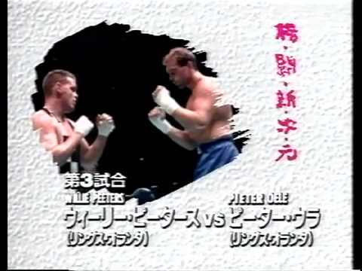
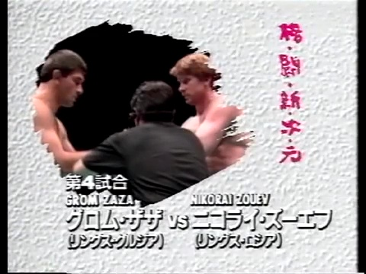
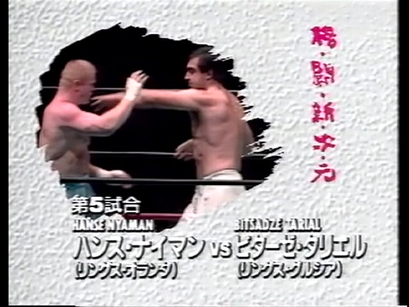
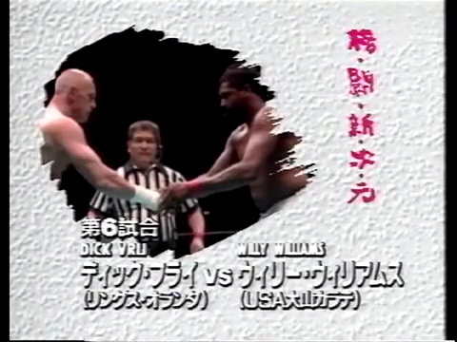
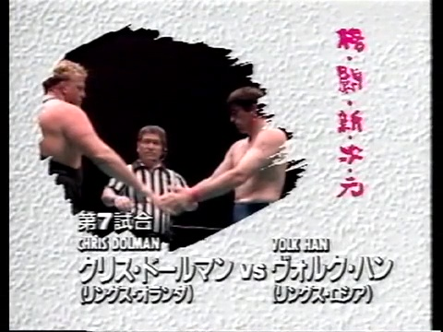
“E Pur si Muove”
“And yet it moves…” This Italian phrase is a potent quote from Galileo Galilei, which is a defiant assertion of his belief in the heliocentric model of the solar system despite his forced recantation under the threat of the Inquisition. Yes, in the face of death, ostracization, and mockery, Galilei was determined to question the dogmas of his day, and his bravery helped to move the entirety of scientific thought to where it is today. However, this powerful act of sedition still holds weight to this very day. In the context of kakutogi history, this tagline underscores the persistence of truth and the enduring quest for it, even in the face of overwhelming denial and opposition. We at the Kakutogi Road have found ourselves in the same situation, as much of this era of history has been poorly documented if examined at all. Not only that but what little has been presented in Western media is simply accepted as fact, with no critical examination from its pundits. Like Galileo before us, we stand to be martyred by the arrows of conventional wisdom, standing on a firm foundation that the truth is worth a lifetime of obscurity if it eventually opens the doors for it to sneak through in the future. Thus, as we reflect on the shifts and turns of this vibrant and evolving scene, we celebrate the emergence of actual combat in professional wrestling. Like Galileo, who steadfastly mapped the heavens, we continue to chart the evolving cosmos of kakutogi, driven by an insatiable desire to discover the profound truths hidden within the art and sport of fighting.
ML: Galileo's best quote is arguably, “All truths are easy to understand once they are discovered; the point is to discover them.” Some of these shows are definitely better than others, but certainly every time I go through these shows, I find things that were done before they were supposed to have been done. It's like the tree falling in the forest, when you first actually go to the forest, and then happen to be there for the right moment, it does make a sound for you.
A typical day of research for the Kakutogi Road…

RINGS BATTLE DIMENSION '93 TOKYO BAY AREA CIRCUIT #3
The date is 8-21-93, and the shoot-style/UWF revolution of the last several years have laid bare many of the norms and assumptions of traditional pro wrestling, partly in a search for the truth and partly in an advanced form of illusion. The early 1990s saw a seismic shift. Visionaries like Sayama, Funaki, and others, peeled back the curtain, exposing the limitations of staged spectacle. Yet, for others like Fujiwara and Maeda, the quest was never just about 'real' vs. 'fake'. It was about a richer, more complex form of entertainment built upon a foundation of authentic combat techniques. Regardless of the motivations behind the changes, I.E., artifice or reality, truth or a lie, the sacred or the profane, actual fighting is starting to emerge, and for that, we rejoice. The situation as it now stands in late 1993 is increasingly dynamic and shifting rapidly. Fujiwara has seen a complete reversal of his fortunes; Pancrase is about to explode onto the scene, the UWF-I is white hot with momentum, and RINGS is somewhere in the middle, having a string of successful events but caught in something of a state of abeyance as their leader, founder, and intrepid hero, Akira Maeda is still recovering from a knee injury. This injury has been so severe to not only Maeda’s health and career but to the very fabric of RINGS’ existence going forward. These circumstances have prompted Maeda to split 1993 into two modes: the smaller “Korakuen Experimental League” events that feature all shoots and his marquee tentpole events that feature worked matches mingled with shoots, only without his presence as the headliner.
As I pull out the ancient scroll for this event (otherwise known as a VHS tape), we are instantly greeted with a lavish production of Akira Maeda's childhood and career. This extravagant production is a shrewd move from the RINGS Braintrust as it continually stokes Maeda's fires within our hearts. We eagerly await his return from self-imposed knee surgery exile. For more information, see our translators’ section at the end of this column where he delves into this segment.
ML: This show saw a stylistic change for RINGS in that all the matches were worked (perhaps because the random shoots have been shifted to the Korakuen Experiment shows), but outside of the main event, they largely followed the formula of being in the Funaki PWFG style of minimal cooperation hard gym sparring. However, on the other side of the spectrum, if they had a finish, it was a rather jarring shift to Hollywood dramatization that, while perhaps more exciting or heroic on paper with the valiant comeback, tended to break the illusion of realism the majority of the match had done a pretty good job of maintaining. It felt like they wanted to guarantee a certain level of drama and excitement, and wanted to have more realistic fights, but the finishes were often too unlikely for these two goals to actually go hand in hand.
Tournament Entry Match: Masayuki Naruse vs. Tigr Levani 30:00
Sadly, it is time for Tigr Levani's second and final appearance. Long-time readers of our columns will remember him from his last appearance in December 1991, when he put on a striking clinic so awful as to make Takayama look like Duane Ludwig. He faces possibly the most versatile RINGS performer of this era until "TK" Tsuyoshi Kosaka hits the scene. Tigr shows much different energy this time, making me think he is operating at his full potential. In contrast, before, he was probably trying to take it easy on Dolman for fear of his life had he made him look bad. The highlight of the first several minutes had to be a sick reverse figure-four variation of an omoplata from Naruse that didn't work, but was on a Volk Han level of innovation. Despite going for 30 minutes, this match was an excellent opener as both men managed to keep it flashy while keeping it a high-energy/low-cooperation affair. Lots of great waza from both men and Tigr was able to make up for his slowness with massive sambo techniques. This was longer than it needed to be, but still lots of fun. *** ½
ML: Levani was a thick powerhouse. His skills seemed to be pretty good now that he wasn't taking on Dullman, but he didn't seem to have much stamina, and was sometimes uncertain of how much to cooperate and how much to sell. This match would have been fine at 5-10 minutes, but 30 was insane! No one with this little experience should be doing a 30-minute match. It's no wonder it took them 5 years to convince him to return for the final time. Naruse, while fine, certainly wasn't up to carrying this for that crazy amount of time. Levani really gutted it out, and they somehow kept a pretty high pace throughout, with no down time. Naruse got a knockdown with a spinning backhand that barely grazed the top of Levani's head. Levani then tried to come back with a couple jumping spin kicks that looked as clumsy as when Chael would venture into Kung Fu Theater territory. Levani stuck with the spinning kicks though, and eventually almost knocked Naruse out with one. Naruse tried to come back by twisting into a wakigatame, but he couldn't get Levani down, and wound up taking a big Dino Bravo side suplex drop. Levani had had enough by the 25 minute mark, and was hunched over with his hands on his knees, ala Mark Coleman. Although neither were holding their hands up anymore, they continued to throw strikes. It mercifully ended, with Naruse getting the decision on points due to a knockdown. This wasn't terrible, but there's only so many things even the best fighters can try in this style, and these two certainly aren't anywhere near the best. Levani grew more confident as the match progressed, but reasonably became somewhat repetitive. This is watchable, but more the kind of match you have on in the background.
Tournament Entry Match 3Min 5Rd: Yoshihisa Yamamoto vs. Mihail Simov R3 1:39
It is time for Yamamoto to face Bulgarian footfighter Mihail Simov in a dreaded boxer vs. wrestler MMA bout. The odds are low that this will be good, but I've been wrong before. Thankfully, this is looking like it might be a proper shoot and, as such, was a welcome addition to tonight's proceedings. Credit must also be given to Yamamoto for always being willing to shoot at a moment's notice. Simov was also a lot craftier than I expected going into this. He kept his strategy to kickboxing, but he adjusted his posture and stance to accommodate the grappling attempts that Yamamoto was going to attempt. He also wisely employed an in-and-out strategy by firing off strikes quickly before backing off. Round 1 saw Yamamoto try and stand and bang with Simov, which yielded nothing but eating punches for his troubles.
Round 2 saw Yamamoto take Simov down, and as he has done in prior shoots, he continued to attempt the STF as if this was a legitimate submission given to us by the catch-wrestling gods all along.
Both men went hard in round 3, eventually seeing Yamamoto take Simov down from an errant low kick. Apparently, the STF is the only submission Yamamoto knows, and he was somehow successful with it. This ending removes any doubt about the validity of this match. It was clearly a work, but a sneaky work, kind of the PWFG style where there really isn’t any cooperation until the pre-planned finish. Therefore, I award this ***.
ML: This match had potential, but seemed to lose steam rather than gain momentum. It began in the PWFG hard gym sparring style with as little cooperation as possible, but then they just spent round 3 limping to the clearly worked finish. Simov wore boxing gloves, so this a lot more of a kickboxer vs. MMA fight than it sounded on paper. Simov was able to land some strikes, but he didn't do anything to control the distance, so Yamamoto kept grabbing him and taking him down, only to have Simov grab the rope for the restart. Yamamoto caught a high kick and turned it into an ankle lock, but Simov, of course, grabbed the ropes. Simov's inability to fight the grip due to the gloves made it easier for Yamamoto to throw him. Yamamoto would have won with the rear naked choke for the same reason, if not for the easy rope escape ruining his fun. After two rounds that were somewhat reactionary, it shifted to very preplanned work in the 3rd. Simov caught Yamamoto's middle kick and took him down to start, trying to work a headlock without much of a grip, but getting almost immediately reversed. Things grew wimpier as the fight progressed, but definitely the lowlight was the finish where Simov just surrendered the leg trip into the modified STF finisher, tapping before Yamamoto even had his hands clasped (he can't see this because he obviously doesn't have eyes on the side or back of his head). This had its moments, and was much better than the opener by virtue of being a reasonable length, but never really came together.
Pieter Oele vs. Willie Peeters 12:01
We've seen both the best of times and the worst of times from Oele. This will be his third match here at RINGS, and in his first, he nearly committed an act of homicide on poor Yamamoto, who stood no chance against him. Then in his 2nd, he was made to play pattycake with Dick Vrij, which was every bit as bad as you would expect. Thankfully, this marks the return of Peeters, our favorite cheatyface whom we haven't seen in a while. Firstly, we must all rejoice as Peeters has returned with his checkered outfit that would make any 2-tone ska band proud. The match starts with a very competitive back-and-forth, which saw Peeters hang with Oele somewhat in the striking department, although it was clear that he would only be able to keep up the direct approach for a while. Then, while trying to employ the sneakiest of judo throws, Peeters injures himself in a way that confuses me and all of Yokohama Arena. Of course, Peeters, being Peeters, takes an opportunity to avenge this slight by kneeing Oele in the balls. This shoot was interesting, as Peeters somewhat had enough athleticism to hang and bang with Oele. Still, he couldn't effectively use his grappling due to Pieter's immense height advantage. He could occasionally take Oele down, but a rope was never far away for the lanky kickboxer. Peeters received his just desserts because the longer this went on, the more he was being pulverized by Oele. By the end, he could hardly walk, and his right ribcage was injured. The two takeaways are that this was a good shoot and that Oele could have been a formidable MMA fighter in the Pride era had he been younger and come up a little later. He has excellent balance and strength to go along with his formidable striking skills, and unlike other kickboxers from this era, he does not seem to be easily taken down.
ML: Spirited, hard nosed standup fight. As usual, Peeters is so stiff that some of his body punches seem legitimate, but he's also doing a bunch of suplexes and showy stuff wherever he can, and more or less every strike here from each is in the same pulled range of landing solidly, nothing grazing and nothing really damaging. Peeters almost immediately injured his knee when Oele didn't go with his hip wheel, and was screaming in pain. I was sure the match was over almost before it even began, but somehow after a brief break, and probably some excess histrionics to milk things, Peeters managed to gut it out. This added drama and urgency to the proceedings, but Peeters wasn't taking it easy on his knee, coming right out throwing kicks to the upper body, and hitting his first of several suplex attempts, a belly to belly. Oele was the much more diverse striker, with a strong muay thai game as well as the size advantage, but Peeters had a lot of determination, and landed hard body punches. Oele wobbled Peters with a stiff jab as Peters was stepping in. Peeters hit another belly to belly suplex, and forced the rope escape with an Americana. Oele tried a standing guillotine, but Peeters stepped forward and tripped him up, then landed a punch that I guess was below the belt because he was scolded by the ref. Oele came back with an unconvincing clinch knee knockdown. Oele tried to go back to the knees on the inside, but Peeters reinjured his knee trying for an ipponzeoi. From here, Oele amped up his knee work, landing a lot of low kicks. He presumably would have kicked more in this fight, but he said afterwards that he injured his knee as well. Peeters got a rear naked choke after another belly to belly suplex, but Oele rope escaped. Peeters blocked a series of kicks, but was dropped with a kick to the liver. From here, Oele went into pro wrestling story mode, and just kept on the liver for the duration. First, he was working body hooks against the ropes, which forced Peeters into retreat. Peeters was soon dropped with another liver kick. Oele began mixing the middle kick, body hook, and the knee to the liver. Peeters was trapped in the corner, and on his final down. He was able to turn out of the corner, and make a good comeback with a series of straight palms, but when he got Oele into the corner, Oele was able to bury a knee into his midsection for the final knockdown. Again, due to Peeters extraordinary stiffness, this seemed like it could be a shoot at times, but as with the Yamamoto vs. Simov match, it seemed to get to a point where the dramatic pro wrestling story kicked in for the scripted finish. This was much better writing with a Hollywood story where Oele focused entirely on Peeters injured ribs, resulting in Peeters milking being on his last leg and final knockdown. This led to the dramatic final stand by Peeters before the expected finish where he went out on his sword due to the rib injury, but without actually quitting or getting KO'd, only because he had no more points to give. Peeters definitely showed a lot of heart in persevering here, even though he lost, so this could have been a strong candidate for an Oscar nod in the screenwriting category, although Steven Spielberg would surely have petitioned to get it disqualified since it didn't have a theatrical release. ***
Nikolai Zouev vs. Grom Zaza 15:59
1993 may be the “Year of Sambo,” as much of its representation in RINGS would have great showings this year. Both of these men would be solid, if unspectacular, performers in later years. However, they were dynamite in 1993. This should be an interesting match as both have much in the way of leglock wizardry, but are novices in crafting a pro wrestling match. It’s amusing to see two sambists try and palm-strike with each other with their odd stances. However, this doesn’t go on for long as Zaza smites Zouev with a thunderous spinning-back slap that was surely not intended to land as flush as it did. A fantastic masterclass in Twister techniques followed where no limb was safe from conforming to a pretzel configuration. However, both men saved this from edging into silly pro wrestling territory by constantly moving quickly and aggressively. The rest was a complete blitzkrieg of every throw, submission, kick, punch, and toehold you can think of. It was sloppy at times, but in the best way possible, as it was passionate sound-n-fury throughout. Eventually, Zouev wins with what is likely the most perverted variation of a neck crank that you will ever see. This may not have had the structure of a Volk Han match, but it was lots of zany fun. ****
ML: Exciting and creative grappling match more or less in the Volk Han style due to Zouev's sambo wizardry, and keen ability to use the opponent's movement or manuever against them. These two can not only wrestle, especially Zaza who was the best pro wrestler who competed in the 1996 Olympics, but what's great is they are able to use the base wrestling lockups to shift to the submission segments in inventive ways, dropping into submissions. They locked up for plum clinches, but Zouev nicely dropped into an armbar. Zouev hooked the leg, but Zaza dropped into a heel hook. Zaza also did a fireman's carry out of the lock up into a knee for a knockdown. Early on, Zaza did an interesting take on the spinning strike where he showed the elbow, then when Zouev reacted to that, he extended for a big chop to the face. This wound up being stiffer than Zaza probably planned because he's just kind of reaching for the face on the spin, and thus can't control the impact the way he might normally when he isn't grasping for contact. Zaza was easily the better wrestler, arguably the better striker, but Zouev had a big advantage in submission skills, and was dangerous anytime there was a transition or scramble. They kept a high pace for 16 minutes, working a fun back and forth match. ***1/4
3Min 5Rd: Bitsadze Tariel vs. Hans Nijman R5 0:39
While Tariel was not quite the blob of molasses here that he would later become, it is a dreaded moment when we must examine one of his matches within these hallowed pages. To make matters worse, Nijman is probably not the man who will get something passable from the Bulgarian beast. However, I owe Tariel an apology, as he is decent in this showing, using good footwork and feints. Nijman was a passable striker compared to some of his other shoot-style contemporaries, but was profoundly lacking when facing a striker the caliber of Bitsadze. This outing wasn't bad by any means. Still, it wasn't a particularly compelling matchup either, but that was mostly due to Nijman not having any answers to Tariel other than just taking him down and doing nothing. Also, Nijman didn't do much in the way of striking other than throwing an occasional high kick before attempting a clinch. The first four rounds of this were fairly legit (in a hard gym sparring kind of way), but the 5th was quick and painfully worked. As such, it's hard to assign a star rating to something like this, but it was passable. ** ¼
ML: These two are both strikers, but Tariel is one of a much higher class, and did a much better job of using feints and jukes to open up his karate, resulting in Nijman being happy to press forward with the body lock to trip him up. After a few minutes, Nijman had clearly conceded that he couldn't hang with Tariel on his feet, and thus shifted to trying to take advantage of Tariel's poor takedown defense, closing the distance and tripping him up to counter Tariel's inside body punching game. Tariel switching stances to open up his strikes kept the stand up interesting, but neither were very skilled on the ground, and Nijman was basically just holding on when he got it there. Too much of this match was just Nijman taking him down and Tariel fighting to get back up. Nijman didn't bother trying any kind of strategic standup or percentage striking, he just threw in the occasional high kick or hook kick, his work rate and connect rate being about equally insufficient. Things got more dramatic in the clearly scripted 5th round that Nijman somehow started with a naked spinning high kick knockdown. Again with the comeback drama, Tariel responded by sort of trying a takedown and having Nijman really help him out by basically pulling him down on top of him. Tariel then somehow submitted Nijman with a deadly side headlock. Tariel was once again pretty good here because he struck the way he was trained to strike in karate, not in the bs pro wrestling manner, but Nijman kind of ruined things by stalling on the ground and just standing around nonchalantly the rest of the time, randomly throwing up a low percentage kick once in a while without ever bothering to put the effort in to set anything up or even trying a combination.
Special Match: Willie Williams vs. Dick Vrij 5R
No matter what happens here, the best part will be Vrij vowing to use more ground technique because Williams is “not a wrestler.” What happened here wasn’t as atrocious as I feared, as both men took this seriously and made an honest effort. It wasn’t perfect. Williams’ knees may be the worst in shoot-style history, but he was still young enough here that he was able to put a lot of energy into what he was doing. Vrij is always a very hit-or-miss component, but he put in real effort, amplified by keeping the majority of this match standing. The only real downside to this match was that it was essentially the same thing every round, meaning it should have been shortened to three rounds for maximum impact. ** ¾
This was the second karate vs. Dutch kickboxing match in a row, which didn't bode well since the 1st one was already way too long and repetitive. Luckily, these guys actually tried, and at least did the promised kickboxing match, with Vrij putting in 100 times the effort that his now cornerman Nijman did earlier. Vrij was pretty good, and Williams did his best. Unfortunately, Williams body can't live up to what his mind knows it needs to do at this point, so the stuff that looked great against Inoki in 1980, looked clunky in 1993. Williams tried to lead with his body punch, but Vrij would use his first strike, usually a punch, to create distance, and then step forward with the low kick. Despite having the reach advantage, Williams wanted to be on the inside to work his karate punches, but Vrij has enough power that Williams had to respect his attacks by backing away. Vrij was chopping the lead leg at the end of every combination, which frustrated Willie, prompting him to throw more and more low kicks. Williams got a knockdown with a clinch knee midway through the 2nd. Williams switched from the body straight to the jab in the second half of the fight because it required less movement and energy, but when he did get close to Vrij, he looked to flurry with knees. Vrij was pretty consistent with the combos ending in the low kick, and was able to take over in the 4th, wobbling Williams a couple times, but Williams actually took him down. Upon getting back up, Vrij was able to drop Williams with the three strike combo due to Williams bad leg giving out. This match was reasonably interesting to start, and if they kept it to 10 or so minutes it would have been worthwhile. Since it's all standup and they don't do many different things, it's diminishing returns at this length, as it just becomes round after round of the same basic ideas. Vrij was not happy that he lost the decision due to one rope escape.
Special Match: Volk Han vs. Chris Dolman 6:20
This is supposed to be a “special match,” although I wonder if that means “special” in the same way as the Olympics or the little yellow school bus. As expected, this may be the worst Volk Han match in history, and probably the only “bad” match he was a part of. Yes, not even the mighty Volkster had enough magic to get something decent out of Dolman, which ended the evening on a sour note. Whenever Han tried to do something, Dolman was an instant wet blanket, refusing to allow any notable action. Sad. *Dud*
ML: This has to be the worst match of Volk Han's great career. I never thought I'd say a Volk Han match was boring, but literally nothing happened here. This was basically the worst case scenario because not only did Dolman typically refuse to move most of the time, but the only actual effort he put into moving was to block or avoid all Han's attempts to do something flashy, entertaining, quick, and/or explosive. Dolman kept the realism up so to speak, at least in terms of how real a supposed competitive MMA match featuring a guy that appears to be 60 and moves in reverse can be, but he did so at the expense of giving us any reason to actually want to watch this turd. Basically nothing was able to happen beyond some holding and laying, but thankfully Han got the victory, at least. Han being in the worst match on the show is unheard of though.
Conclusion: This event was front-loaded. After the 4th match, I thought we had tons of momentum, but the last three matches killed it to the point where you almost forgot that there was anything worthwhile on this show. Taking a step back, it's clear that there are some valuable moments, especially the great match with Zaza/Zouev, but ending the night with two overlong matches and a dreadful main event is not the way forward. All that aside, the real takeaway is that it's clear that RINGS is a listless vessel without Maeda at the helm. There isn't enough homegrown star power to keep this outfit afloat once Maeda does retire unless they either figure out a way to raise some fresh stars or find a way to completely switch over to a full-blown MMA format that the public will accept. We have to give Maeda credit for having the foresight to be at least willing to experiment with full shoot-cards, as evidenced by the Korakuen Experimental League. Still, he isn't willing to bet the farm on the concept just yet.
ML: Dolman and Williams are two of the only “names” on the show, but they are too old and too dull to be featured on a show that seemingly wants to be considered real fighting. Maeda is indebted to Dolman for providing the Netherlands fighters, and feels compelled to put someone people have heard of on top, but they need someone other than Vrij who can provide Han with a real match that they also believe can draw since they already had the Han vs. Vrij rematch on the last show. I think they'd be better off just having Han beat his sambo compatriots that have the skill to have a match with him and having Vrij beating kickboxers who can strike with him, throwing the natives to the wolves once in a while, so you at least build two compelling names on top while you wait for Maeda to return, rather than trying to get short term margins at the box office on hasbeens like Dolman and Williams in exchange for the long term health of the company.
Krummel’s Korner
Our most esteemed translator, John Krummel, really went hard into the pain this time with his detailed examination of this event. Here are his findings:
Akira Maeda 15 years debut anniversary event
New fighting dimension
Aug 31, 1993, Yokohama Arena:

Starting narration: Akira Maeda, mixed martial artist, born January 14, 1959, in Osaka. This is his 15th year since his debut. During those 15 years, he encountered various individuals and engendered various stories. As we look back, each scene of those years had significance in having contributed to forming the RINGS of today. Let us look back on his history as we look forward to the future.
What led to Maeda becoming called the “fighting king” today was due to his meeting with his karate teacher Shōgo Tanaka. Akira Maeda at the time was 17 years old, and was known as a street fighter. Full of confidence, Maeda challenged Tanaka and their fight, we can say, was the start of Maeda’s fighting life. Without encountering Shōgo Tanaka and becoming friends with Tanaka, his life as a fighter would not have begun. In 1977, Maeda has another fateful encounter. Hisashi Shinma, who at the time was Antonio Inoki’s manager at New Japan Pro Wrestling contacted Maeda. Maeda, accompanied by Tanaka, met Shinma at the Osaka Royal Hotel. The next day, Maeda moves to Tokyo and meets Antonio Inoki, who will have a huge impact on his life. Following this meeting, his entrance into New Japan Pro Wrestling was decided within a week. The plan was for him to train for three months. We can say that this was all destiny moving him to become the “fighting king.” In 1979, together with Yoshiaki Fujiwara, Maeda is promoted to be Inoki’s personal attendant. Once while sparring at the dojo, Maeda lost his temper and kneed and struck his training partner. Seeing this, an angered Inoki struck him, shouting, “pro wrestling is not murder!” Is it really that pointless to train to strengthen oneself and test one’s abilities to the furthest limits in sparring, with the least amount of rules? In this we can see Maeda’s attachment to the fundamental principles of combat.
In 1980, he meets Karl Gotch. This encounter awoke him to pro wrestling and its way of life. It was an accidental meeting, but an encounter with someone who Maeda would come to consider his greatest teacher in life. Without these accidental encounters with Shōgo Tanaka and Karl Gotch, Maeda would not be who he is today. We cannot but feel the energy here of fate. In his 3rd year in New Japan pro wrestling, while resting in Tokyo due to a ligament injury of his left knee from a match, Maeda received the big news that Gotch will be staying at the Takamoto Clinic in Beppu and that he was to take care of Gotch. Maeda knew of Gotch’s greatness and knew that many wrestlers, like Fujinami, matured as wrestlers, after training with Gotch. During the month and a half, he spent with Gotch, Gotch taught him all sorts of things. Gotch taught him about techniques, spirit, and also about the time when pro wrestling was a real combat sport. This made Maeda resolve to continue on this path. The 3 years spent in NJPW, from 1980 to 83, for Maeda were years of struggle and anxiety. The distance from the pro wrestling he learned from Gotch was steadily getting larger. On Jan 25, 1983, he was given the chance to challenge Karl Gotch’s old friend Wayne Bridge at the Royal Albert Hall for the European heavy wt. title. It was a 2 out of 3 falls, match with 5 rounds of 5 minutes. After losing the first fall, Maeda hit Bridge with three kicks, followed by a suplex, to win a fall. Due to damage received from the suplex, Bridge was unable to fight, and Maeda won the 2nd fall due to referee stoppage.
The original UWF was the best years for Maeda. There were many great fights, starting with his match against Yoshiaki Fujiwara; and the fights confirmed the reality that both the wrestlers and the fans were searching for. During this period, many young trainees joined UWF. Miroki Mori was one of them. This year, 1993, Maeda met Mori again. Mori, had not altered his vision since his UWF days and was still training in Osaka and teaching younger trainees. The original UWF had such an impact that it gave birth to individuals like Mori. In 1988 the Newborn UWF had its start with the cooperation of many people and support of many fans. Nobuhiko Takada, Kazuo Yamazaki, and youngsters like Anjoh, Miyato, and Nakano, took part, with also the joining of Yoshiaki Fujiwara, Funaki, Suzuki. He also meets Chris Dolman and Dick Vrij, during this time. Under the support of many fans, the Newborn UWF was a great success. There were many great fights, such as his fight against Gerard Gordeau in 1988. In 1989, they had a successful show at the Tokyo Dome. There was such a momentum for NUWF at the time, with Akira Maeda at the center. Then NUWF suddenly dissolved, which for Maeda himself was totally unexpected. His dream was broken. But the truth had already been carved into his heart.
On May 1991, he founds the Fighting Network RINGS. This is probably the only time when a sole individual founded a fighting organization alone. Then the RINGS Holland members, Chris Dolman and Dick Vrij joined to participate; followed the members of RINGS Russia, Georgia, and Bulgaria, starting with Volk Han; and the joining of Mitsuya Nagai; and the involvement of Willie Williams. With these additions the network has certainly been spreading. Following Maeda’s words that RINGS will decide who is the strongest in the world, RINGS will continue to develop into the future. Please look forward to it!
Maeda’s on-ring announcement: “I have been absent from the ring for half a year due to injuries, but after a series of surgeries, from October I have been undergoing rehabilitation therapy. After discussing with the RINGS council members, I have surrendered by 3rd place ranking. I will enter the coming tournament as an unranked fighter, starting anew in both spirit and body. I will do my best to show you a strong Maeda. And I declare that I will win this year’s tournament! I ask you to keep cheering for Akira Maeda!”
Tournament entree bout: Masayuki Naruse (RINGS Japan) vs. Tigr Levani (RINGS Georgia) 30:00
Naruse: 177cm, 92kg; Born March 15, 1973 in Tokyo; started training in Shotokan karate as a high school student, currently shodan (1st degree blackbelt). In April 1991, passed the RINGS entrance test despite being under the height limit due to his fighting sense. Had good fights against Zouev in Feb and against Kakuda in March at the Experimental League. The fans appreciate his fighting spirit as a professional.
Naruse’s prefight comments: “This might not sound like me, but I plan to win regardless of the tactics. It doesn't matter whether the fight goes the full time limit of 30 minutes or whether it’s by decision or by disqualification. In any case, unless I win this match, the path will not be open to me. I think that this match will have a real effect on my future, whether I win or lose, so for the sake of my future self, I plan to go for the win in today’s match.”
Levani: 184cm, 117kg; Born 1957 in Georgia. In 1985 won the European championship in freestyle wrestling; in 1990 took 2nd place in the Soviet Union championship. Under the recommendation of Nodali of RINGS Georgia, he is a candidate to enter the tournament. “Tigr” in Russian means “tiger.”
Levani’s prefight comments: Q: “You haven’t fought in RINGS for a while”; A: “There were no problems. I’ve just been training for a whole year so that I can win in RINGS.” Q: “Your match with Naruse will determine your entrée into the tournament.” A: “I’ve heard that Naruse is very sharp. I think I can show the effect of my training on the ring.
Naruse’s postfight commens: “That was embarrassing… I needed 5 more seconds, or even 2 more seconds…”
Tournament entrée bout: 3Min 5Rd: Yoshihisa Yamamoto (RINGS Japan) vs. Mihail Simov (RINGS Bulgaria) R3 1:39
Yamamoto: 190cm, 90kg; Born July 4, 1970 in Yamaguchi Prefecture. Trained in judo in high school and passed the first RINGS entrance test and started training at Maeda Dojo in May 1991. Won his first pro fight against Nishi in January 1993. RINGS has high expectations of him.
Yamamoto’s prefight comments: “My bad habit is to panic, so today I’m going to stay calm, and I want to submit him quickly on the ground.” Q: “Do you have ground techniques specifically for an opponent wearing gloves?” A: “Yeah, the point is how to get the stand-up fighter to the ground. I want to finish the fight as quickly as possible. The longer the fights lasts, the harder it will be since he’s 10kgs or so heavier than me. So his strikes will be heavy, and I would receive more damage the longer the fight lasts. So I want to submit him swiftly.”
Simov: 190cm, 105kg; Born Oct 23, 1963 in Bulgaria. Has trained in karate and kickboxing. In karate, won the 1986 Bulgarian championships and took 2nd place in the 1990 European championships. In kickboxing became the 1992 European champion.
Simov’s prefight comments: Q: “What are your thoughts on Yamamoto?” A: “I saw Yamamoto only on video, but I think he’s a good fighter. But I have confidence in my punches and kicks so I’m not too worried.”
Yamamoto’s postfight comments: Because Naruse fought first to enter the tournament, I was under pressure. If Naruse gets in the tournament, I’d have to get in too. But since he won, that sparked my determination… In the fight with Kandalaky, I got hit a lot on my face, but this time, it seemed like Simov didn’t know any sambo, so once I got him down, it was easy to do what I wanted to do.”
Pieter Oele (RINGS Holland) vs. Willie Peeters (RINGS Holland) 12:01
Oele: 193cm, 108kg; Born May 14, 1965 in Amsterdam. 1988 Dutch kickboxing champion. Aside from kickboxing, he’s been training in freestyle and Greco-Roman wrestling and also sambo under Chris Dollman and his sambo techniques are said to be upper-level.
Oele’s prefight comments: In English.
Peters: 180cm, 90kg; Born in Ernwin in 1965; Won the 1987 Dutch amateur wrestling Greco-Roman 82kg wt. class. Began training in kickboxing 4 years ago and possesses the record of 12 matches, 11 wins (8 KO) and 1 loss.
Peters’ prefight comments: In English.
Oele’s postfight comments: In English
Tournament special rules: 30mins 1 fall: Nikolai Zouev (RINGS Russia) vs. Grom Zaza (RINGS Georgia) 15:59
Zouev: 188cm, 98kg; Born May 20, 1958; Interested in combat sports from a young age and studied sambo and combat sambo. He has won the Soviet Union sambo championships. Currently he works within Russia as an instructor of sambo. Some say that in technique and sharpness of technique, he exceeds even Han and Kopilov.
Zouev’s prefight comments: Q: “What are your thoughts before the fight?” A: “I intend to showcase the techniques I teach of Russian sambo in the match.” Q: “Zaza was a World Cup champion.” A: “Yes, in order to counter his wrestling, I will probably need to take control with the ‘techniques’ and ‘tactics’ of sambo. I’ve heard that Zaza is very strong, so I will use everything I’ve got to beat him.”
Zaza: 188cm, 103kg; Born March 19, 1961, in Georgia. Won the 1986 freestyle wrestling European championships and also won the World Cup. He has no experience in other combat sports, but he claims that freestyle wrestling, just as its name states, can freely respond to any style, including kicks and submissions.
Zaza’s prefight comments: Q: “Your opponent will be Zouev, an expert in Russian sambo.” A: “His joint lock submission are certainly dangerous. I will do my best to win.” Q: “How is your condition?” A: My condition is very good, and I think we will have a good fight.”
Zouev’s postfight comments: “This is my second time to fight on the mat of RINGS, but two times is still not enough to get used to the techniques of each fighter since they’re all different in their techniques. I’ll come to get used to the RINGS style of fighting as I fight here more times.”
3Min 5Rd: Bitsadze Tariel (RINGS Georgia) vs. Hans Nijman (RINGS Holland) R5 0:39
Tariel: 200cm, 105kg; Born Jan 12, 1966, in the People’s Republic of Georgia. He had a good fight against Andy Hug at the 5th Kyokushinkaikan Open Tournament karate championships. Aside from karate, he’s also known as a discus thrower and holds a record in discus throwing in Georgia and was on the Soviet Union team for discus throwing. He is a large-scale fighter representing Georgia.
Tariel’s prefight comments: Q: “You will be facing Nijman who is also a karate-ka.” A: “His karate ‘technique’ is very high. But as a karate-ka, I intend to respond to his techniques and do my best.” Q: “How will you respond to ground attacks?” A: “As for ground attacks, I haven’t paid too much attention in the past to ground fighting, but this time I did train in ground fighting. And I intend to fight with conviction in the techniques of our ‘national sport’ of chitaoba [Georgian jacket wrestling] that is a part of my ‘body’ since I’m Georgian.”
Nijman: Born Sep 23, 1959. He has an impressive record as a top fighter in the Dutch karate world. He has won the European championships twice and in 1990 took 3rd in the WUKO world championships. Even when losing in a row to Maeda in June and to Vrij in July of last year, he still showed what he is capable of. There is something spectacular in the speed and sharpness of his striking despite being a heavyweight. And he is also capable in ground fighting.
Nijman’s prefight comments: In English.
[weird finish by Tariel]
Tariel’s postfight comments: “Nijman was very strong, but his punches were not effective. Punches are my forte, so even though it was a difficult fight I felt from the initial lock-up that I can win.”
Special Match: Willie Williams (USA Oyama Karate) vs. Dick Vrij (Ring Holland) 5R.
Williams: 200cm, 110kg; Born April 14, 1951 in America; began studying karate from the age of 19 and earns a blackbelt at the age of 21. Won the New York karate championships and took 3rd place in the 2nd Kyokushin Karate world tournament. Nicknamed the “bear killer” due to his fight with a bear in the film, “World’s Strongest Karate” [titled “Fighting Black Kings” in the US]. He showed his abilities in the November RINGS show.
Williams’ prefight comments: In English.
Vrij: 187cm, 114kg; Born 1965 in Harlem, Holland. Began body building at the age of 16 and began kickboxing at age of 19. Nicknamed cyborg due to his built up body with very little fat. He showed how dangerous he can be in his fight with Nagai. He is considered the “ace” of Holland.
Vrij’s prefight comments: In English.
Williams’ postfight comments: In English.
Special Match: Volk Han (RINGS Russia) vs. Chris Dolman (RINGS Holland) 6:20
Han: 190cm, 105kg; Born April 16, 1961 in Northern Caucasus of the Soviet Union; Instructor of the army and police as an expert in combat sambo. Took 2nd place in the 1984 sambo Soviet Union championships; and won the 1985 Soveit Union open wt. division. Multiversatile in his techniques, and his fighting style that can hook submissions from any position is sensational. Currently ranked 5th.
Han’s prefight comments: Q: “This will be a match with Dolman who is ranked at the top”; A: “I’m not particularly afraid of Dolman, but I’ll have to be careful of his choke holds.” Q: “Was there any damage from your loss against Vrij?” A: “This time I used my disappointment from that match as a springboard to train hard. So I promise I will be the winner in this match.”
Dolman: 187cm, 117kg; Born in 1945 in Amsterdam; Won the 1966 European judo championships, the 1971 Netherlands judo championships; and the 1984 and 1985 sambo world championships. He has a terrific record as a judoka and sambist who represents Holland [Netherlands].
Dolman’s prefight comments: In English.
Dolman’s postfight comments: In English.
Han’s postfight comments: “It was my first time to fight that type of fighter like Dolman. I’m very happy that I was able to beat him who was at the top in the rankings. The strategy determined who will win or lose in today’s match and at first I was confused about this.”
*In Other News*
Former AWA President and legendary champion, Verne Gagne, made headlines across the nation as news of his bankruptcy filing surfaced last Friday. At 67, Gagne found himself seeking protection against a daunting $2 million real estate debt, a predicament stemming from financial troubles surrounding a St. Louis Park office building co-owned with his son Greg and Mark Senn. The building, housing Gagne's Minneapolis Boxing & Wrestling Club, fell into arrears, resulting in a legal tussle with Senn, who held Gagne personally responsible for lease payments. With the building partnership lagging behind in mortgage payments to Norwest Bank of Minneapolis, a $1 million lawsuit from the bank further compounded Gagne's financial woes, prompting his bankruptcy filing.
Gagne's attorney emphasized that the bankruptcy filing was a strategic move to shield him from potential liabilities exceeding $2 million, rather than an indication of complete financial destitution. In his filing, Gagne listed his primary asset as his Eden Prairie, MN home valued at $300,000, with total assets below $500,000 and debts exceeding $1 million. Gagne's illustrious career traces back to his days as a football star and NCAA wrestling champion at the University of Minnesota, where he earned induction into the sport's Hall-of-Fame. Rising as a local hero in Minneapolis, Gagne became a prominent figure in the wrestling scene during the 1950s, establishing his own promotion, the AWA, and securing the world heavyweight championship.
Under Gagne's reign, the AWA thrived for two decades, expanding its reach from Denver to San Francisco, and from Winnipeg to Chicago. Despite a successful career on-and-off in the ring until his retirement match in 1981, Gagne's legacy faced challenges as the AWA struggled to adapt to the changing landscape of professional wrestling. The departure of key talent like Hulk Hogan in 1983 marked the beginning of the AWA's decline, ultimately leading to its closure in 1990. Gagne's son Greg, a wrestler for the AWA until its demise, has since transitioned to working in the WCW front office, carrying on the family's wrestling legacy in a different capacity.
In a high-stakes legal maneuver, Jean-Claude Van Damme's legal team launches an appeal against a court ruling mandating nearly $400,000 in damages for negligence in an incident on the set of "Cyborg" (1988), where a stuntman was gravely injured. Seeking a reduction in the awarded damages, Van Damme's attorneys are met with fierce opposition as lawyers representing the injured stuntman counter-appeal, advocating for the reinstatement of the original $800,000 in damages coupled with punitive measures. This legal showdown underscores the intensity of the ongoing dispute and the complex legal ramifications surrounding on-set safety in the film industry.
As UWF-I continues to carve its niche in the realm of combat sports, the challenge of educating the American audience looms large, particularly with the impending October 5th PPV featuring the 7/18 Sumo Hall event. Amidst anticipation for the Takada vs. Salman Hashimikov main event, concerns arise over potential clashes with WCW regarding Vader's participation, given their supposed exclusivity on his U.S. appearances. Nonetheless, UWFI's TV show endeavors to bridge the gap, with legendary Lou Thesz igniting intrigue by proclaiming the victor would vie for supremacy against WCW's Vader, fueling the quest for the ultimate world champion. Takada's undeniable star quality shines bright, with his magnetic presence eclipsing contemporaries, while Albright's bold declaration post-victory adds fuel to the fiery UWF-I narrative, signaling a paradigm shift in the landscape of Japanese wrestling.
In a strategic move geared towards maximizing the spectacle, the highly anticipated RINGS event slated for 11/13 at Tokyo Bay NK Hall has been rescheduled to 11/18 at Sumo Hall. The decision comes as no surprise, given the monumental significance of Akira Maeda's long-awaited return to the ring. Recognizing the magnitude of Maeda's comeback, organizers opt for a larger venue to accommodate the fervent anticipation surrounding this historic moment. As excitement mounts, the stage is set for a monumental evening of combat sports, promising thrills and surprises that transcend the confines of traditional wrestling events.
Masakatsu Funaki's Pancrase Wrestling hosted an opportunity of a lifetime on 7/29, inviting aspiring talents to showcase their potential at tryouts for coveted training spots. With the allure of stepping into the world of Pancrase, where grit meets technique in the crucible of combat, hopefuls seized the chance to prove their mettle. Beyond a mere audition, it was a gateway to a realm where passion converges with discipline, promising the forging of future champions amidst the sweat and determination of those hungry for glory.

