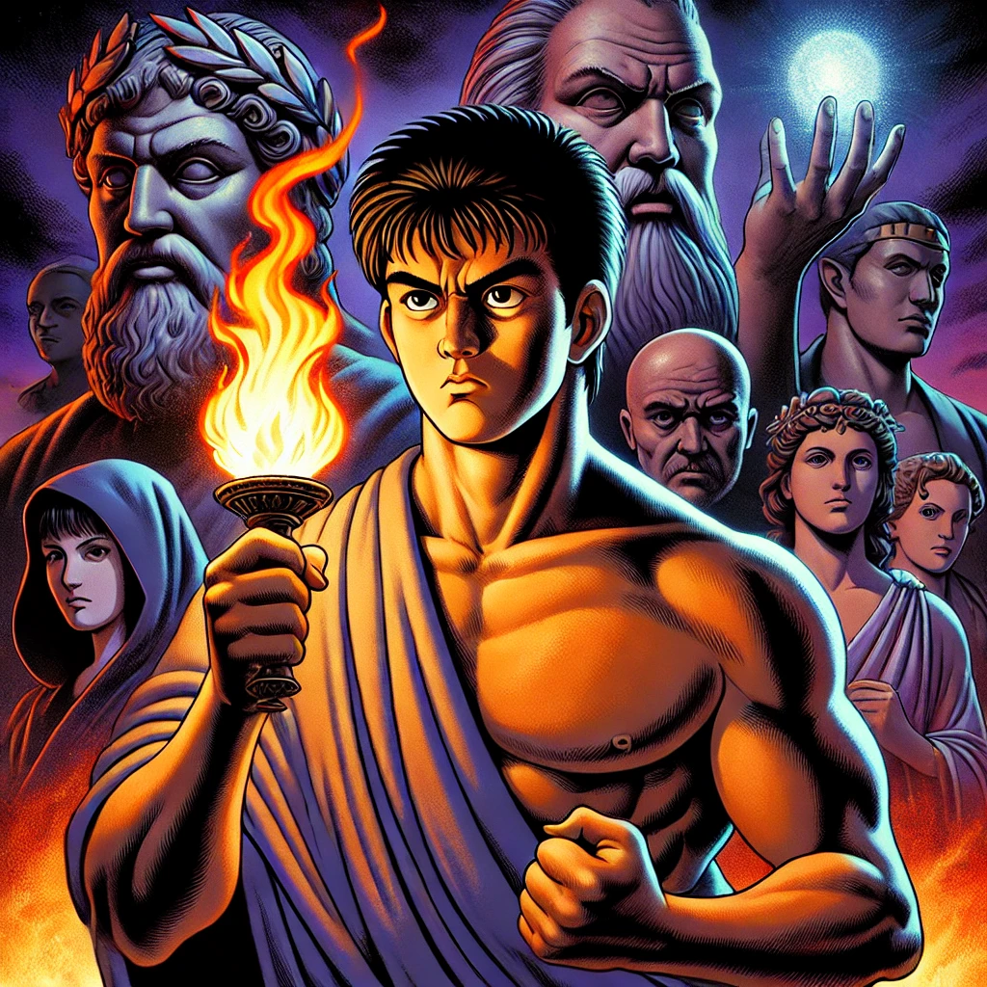
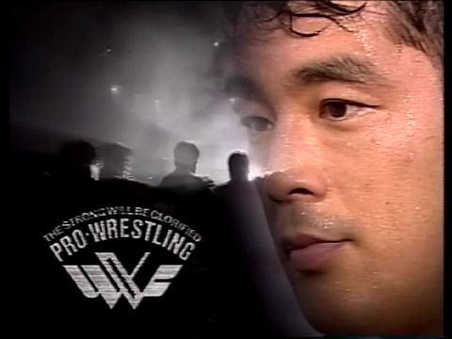
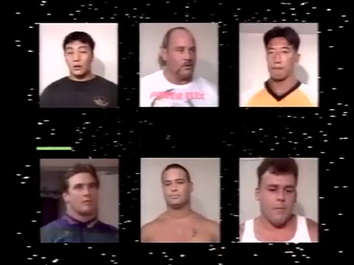
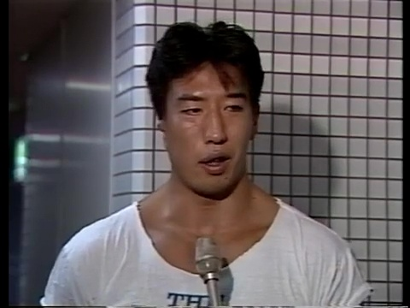
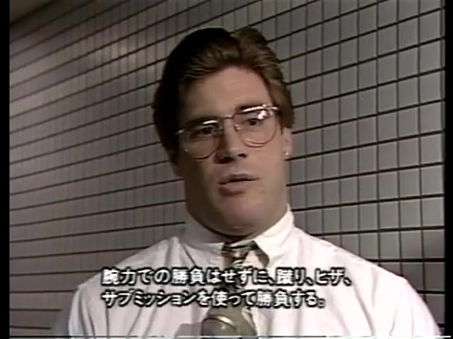
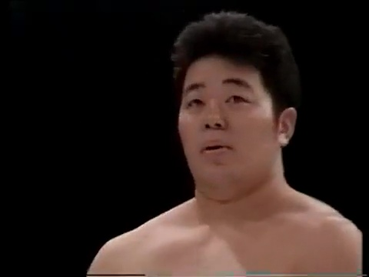
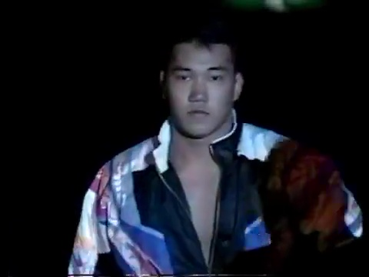
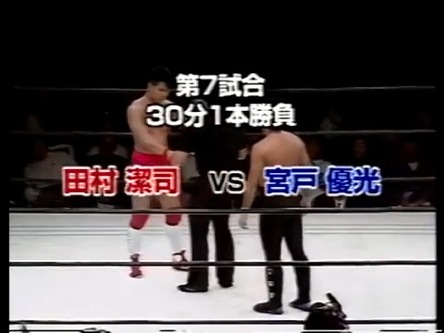
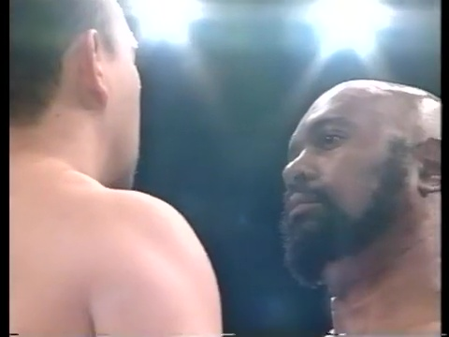
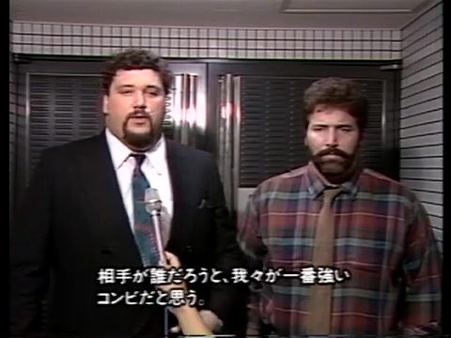
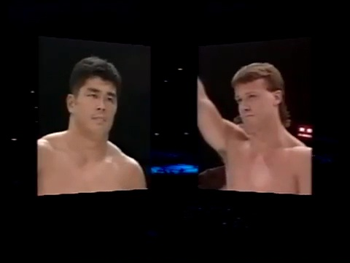
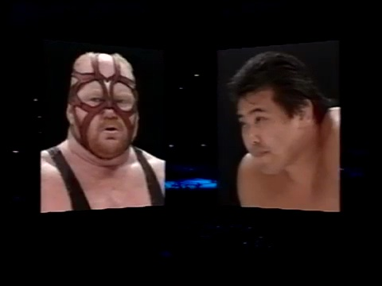
Kakutogi Road: The Complete History of MMA Volume 82: Prometheus: A Grift of Fire and Folly
“I taught them all the skills I could devise and, when my resources were exhausted, I sought new ways.” –Prometheus
Prometheus, the defiant god, dared to steal fire from the heavens and gift it to mankind. But even he, in his boundless generosity, could not have fathomed the depths of human deceit, the way mortals would twist this divine power for their own selfish ends. Nobuhiko Takada, the charismatic showman of Japanese professional wrestling, was one such mortal.

In 1984, Takada found himself drawn into the UWF, a maelstrom of rebellious spirits seeking to shatter the illusion of pro wrestling and forge a new path – one paved with the brutal reality of shoot-style combat. He witnessed the likes of Inoki, the stoic emperor of the ring, grapple with this forbidden knowledge, wielding it with a calculated restraint, a magician carefully revealing only the tricks that served his reign. But Takada, the audacious trickster, saw an opportunity to seize the flames for himself. He was no master of the craft, no disciple of the sacred art. He was a performer, a weaver of captivating narratives, a master illusionist disguised as a warrior. He saw in shoot-style not a path to enlightenment, but a ladder to climb, a stage to command.
Unlike Sayama, the fiery revolutionary who sought to push the boundaries of human potential, or Fujiwara, the devoted student who honored the legacy of catch wrestling, Takada possessed no such noble intentions. He was a hollow vessel, a gilded cage devoid of the true fighting spirit. His ambition was a wildfire, fueled by ego and the intoxicating allure of fame and fortune. And for a time, it worked. Takada, the self-proclaimed "master" of shoot-style, basked in the adoration of the masses, his carefully crafted persona masking the emptiness within. He spun tales of legendary battles, his every move, a calculated deception, his every word a carefully rehearsed lie.
But the truth, like a smoldering ember, threatened to ignite the facade. The reckoning loomed on the horizon, in the form of a looming showdown with the legendary Rickson Gracie, a man who embodied the very essence of true combat. This clash, a collision of myth and reality, would expose Takada's fraudulent reign and reduce his carefully constructed empire to ashes. Yet, in this moment of hubris, Takada stood atop the world, blinded by the dazzling lights of his own making. He was the Promethean imposter, a man who dared to play with fire without understanding its true power. And like the tragic titan himself, he was destined to fall, consumed by the very flames he sought to control. For as Prometheus lamented, “I know that I am doomed to suffer."
"And why not?" said I instantly to myself. "Prometheus heretofore went up to Heaven, and stole fire from thence. Have not I as much Boldness as he? And why should not I, then, expect as favourable a Success?" - Cyrano de Bergerac
ML: The boldness of Takada greatly exceeded the boldness of the titular character of Edmond Rostand's famous play Cyrano de Bergerac, but both shared the hope that they could beat the odds, defy heaven and earth, in their own way. Cyrano, of course, was a representation of inner beauty, who hid behind Christian, the representative of outer beauty to try to get what he wanted (the love of Roxanne). Takada is much more toward Christian, all gloss and no substance, and unfortunately his Cyrano, Yuko Miyato, isn't exactly one of the world's great minds...
Kazushi Sakuraba vs. Mark Silver 7:14
Ah, the nascent journey of a Gracie-Hunter! So far, Sakuraba has shown us nothing but boundless potential, though his opportunities to shine have been limited in his last two matches. This marks his third outing, and while it's clear Miyato isn’t ready to give him the spotlight just yet, glimpses of his future greatness still manage to slip through. Sakuraba's creativity—his striking and fluid movement—was already evident, even if we only got brief flashes of it before Silver took the fight to the ground.
To his credit, Silver was explosive here, giving the match the weight it needed to feel believable, though he still struggles with the finer points, particularly in setting up submissions. Sakuraba, constrained to flourish only in short bursts, is difficult to critique given these limitations. But considering both men were still raw rookies at this stage, this was a respectable opening match—one that hints at the remarkable journey Sakuraba is just beginning. Overall, it felt a little under seasoned, but there was a lot to like here. ** ¾
ML: This was basically just a much larger wrestler squashing a poor rookie. We got a better, more aggressive, and urgent performance from Silver though. He didn't mess around in stand up. He got in quickly, and tossed Sakuraba to the ground hard. Granted, his suplexes were the least realistic portion of the match, which was otherwise surprisingly pretty realistic, but they also provided some much needed entertainment value, whereas the matwork was kind of dry. The problem with this match, and many involving the American amateur wrestlers, is they don't really have submissions, but no one wants to see them just hold the opponent down. Sakuraba, who was wrestling his 3rd match, was never allowed to get his ground game going to provide any kind of threat. Silver did a massive uranage, perhaps the highest impact one I've ever seen, basically bouncing Sakuraba off the canvas then finished with the rear naked choke. It was fine for what it was.
2nd Junior League Match: Hiromitsu Kanehara vs. Tommy Cairo 3:49
By now, in what feels like our 82nd scroll through the vast archives of the Kakutogi Road, it’s almost redundant to point out Miyato’s chronic mishandling of talent. Instead of a game-changing series like Kanehara vs. Maeda, we’re caught in an endless loop of Junior Tournament matches, which feels a bit like searching for enlightenment amidst reruns of Acapulco H.E.A.T.—it sounds promising on paper, but leaves you somehow underwhelmed.
This match was an hors d'oeuvre—a brief, tantalizing taste of Kanehara’s potential. Clocking in at under four minutes, it was thrilling while it lasted, but far too fleeting to feel meaningful. On the plus side, the short duration worked to Cairo’s benefit, masking some of his weaknesses, while Kanehara was pure fire from start to finish. ** ¼
ML: Kanehara had a few moments, but it was too short to amount to anything. The finish was good, with Kanehara defending the takedown and landing a knee to the chest to put Cairo to his butt, then landing a brutal knee to the head with Cairo sitting there prone for the knockout.
2nd Junior League Match: Yoshihiro Takayama vs. Thomas Burton 11:12
As if I haven’t already flogged the proverbial dead horse over Miyato’s misguided booking, here we have another prime example. This match stretched to nearly twelve minutes—a luxury that would have been far better spent on the previous two bouts. For Takayama and Burton, though, it might as well have been an eternity. While both men could hold their own under the right conditions, pairing them here was a recipe for mediocrity rather than magic. Takayama showed flashes of spirit in the grappling sequences, but every kick he aimed at Burton felt like he was tiptoeing around a porcelain teapot, reluctant to commit. While this was certainly a step above some of the overlong wandering affairs we’ve endured from RINGS and PWFG, it was still a disappointment born from the brain-trust's persistent poor matchmaking. **
ML: This was typically awful and way too long. It was slow, but never realistic or entertaining. Takayama somehow managed to draw blood, scratching Burton's forehead with a short palm strike while trying to fend off the Achilles tendon hold. During the early portion, Takayama kept it really simple, and managed to look slightly less inept than usual. There's greatly diminishing returns with him, but they keep tempting fate leaving him out there to embarrass himself even though there's plenty of capable guys whose match they could add a few minutes to. This was quite dull, with some pretty bland matwork. Burton decided to spice things up with a lariat and a double arm suplex for a knockdown. Takayama answered with his own knockdown from a knee to the midsection, and took a cheap shot stomping Burton while he was down. Takayama went on a run from here, fumbling for more submissions until Burton countered some sort of improperly applied standing arm bar attempt with a side suplex drop. Burton tried to control with what might have been a guillotine attempt, but Takayama countered into a sloppy chickenwing armlock for the win. This was typically awful and way too long.
2nd Junior League Match: Greg Bobchick vs. Gene Lydick 7:37
Right from the start, Gene Lydick exudes serious Gordon Gekko vibes, proudly talking up his commitment to kickboxing classes squeezed in between venture capital duties. Facing him is Greg Bobchick, a solid but otherwise unremarkable wrestler, one of the many interchangeable faces the UWF-I keeps sending our way.
As expected from a wrestler vs. wrestler matchup in this style, it delivered a steady, if unremarkable, display of fundamentals. Bobchick showed more athleticism and technical skill in wrestling, while Lydick, though a bit outclassed by the Japanese talent, appeared impressively versatile by comparison, looking almost like a submission wizard next to Bobchick. The match was better than anticipated, with both men working hard within their limitations. They may not have had the arsenal to elevate this bout to greatness, but their effort kept it engaging. ** ¾
ML: In Oliver Stone's Wall Street, Gordon Gekko famously stated, "What's worth doing is worth doing for money", hence the professional career of one of the most energetic and exciting American wrestlers of the shoot wrestling era, Gene Lydick. Amateur wrestler battles don't make for the best matchups, but it was competitive, and more in the spirit of what this league is actually supposed to be presenting. This was the best match so far. Inoffensive, but still very skippable. It didn't have a lot of highlights. It just kind of went along fairly credibly, then they did a couple of spots and went home. They took it seriously, and stuck to what was plausible. When they finally did a big spot, it didn't work the way they wanted it to. Lydick was trying to make his German suplex look hard way, but in pulling that off, Bobchick wound up coming down on Lydick's nose. Lydick adjusted his next German suplex accordingly, raising his waist lock, arching his back more, and even twisting so he actually came down on his side while still putting Bobchick down on his back. Lydick then went into an arm bar for the finish.
Yoji Anjo vs. Tatsuo Nakano 9:22
With Anjo and Nakano, you know what you’re signing up for: a solid, if somewhat predictable, clash of styles. This time, however, Anjo took a more cerebral approach, peppering Nakano with fierce kicks from a distance while using parrying and footwork to keep Nakano’s clinch attempts at bay. The match played out as a tug-of-war, with one man determined to avoid the ground and the other just as determined to take him there. Anjo carried this strategy well, showing impressive control and patience, but Nakano seemed a touch disengaged, not quite leaning into his role enough to fully sell the story. While good as it was, the match would have benefited from a bit more time and a more invested Nakano to elevate the dynamics. ***
ML: Moving on to the seasoned professionals, we got the most capably performed match thus far. By the way it was worked, I would have guessed this was going twice as long as it actually did. Having a bunch of short matches when it's supposed to be shoot style isn't a bad idea, but the fighters need to approach them with energy and urgency. Instead, Nakano was still acting like this was one of his 30 minute UWF time fillers with Miyato because the Newborn U.W.F. only had enough fighters to put on 3 matches. This match just never really got going. There was a moment here or there, a flash of their fire or dickishness, but the spark never caught fire despite these being two of the most emotional performers in the company. Nakano's nose bled more than usual, but there weren't really that many strikes considering both are standup fighters. Nakano got good reactions for his suplex attempts, but only actually hit a Dragon suplex before Anjo choked him out. At best, this was an average match that greatly underachieved because they mostly durdled on the canvas.
Masahito Kakihara vs. Dennis Koslowski 8:55
On paper, this is an intriguing matchup: Koslowski’s phenomenal wrestling against Kakihara, who arguably has the fastest hands in the East. The opening seconds of a Kakihara match are always electric, though the question usually isn’t if he’ll end up on the ground, but when—and with someone as skilled as Koslowski, the answer came quickly. Still, Kakihara is an underrated grappler, and while he couldn’t keep the fight standing for as long as we’d like, he had a few surprises up his sleeve that kept Koslowski guessing. The match delivered some excellent individual moments, though it occasionally stumbled in its overall flow. A standout highlight was when Kakihara executed one of the slickest takedowns we’ve seen yet, effortlessly somersaulting Koslowski onto the canvas. The ending was a bit abrupt, and Koslowski is still green in this style, but this was easily the best match so far. *** ¼
ML: Kakihara brought the energy we've been waiting for all show, but after his initial flurry, he reasonably had a hard time keeping Koslowski off him. Kakihara was forced to attack with submissions to either avoid the takedown or create an opportunity to get back to his feet. As is typical for Kakihara, this wasn't as realistic as some of the other matches, but it had more excitement, and followed the logical strategies. Kakihara was getting off first, but Koslowski would keep coming forward, and being the much larger man, could absorb a shot or two in order to get in for the takedown. Kakihara decided to gamble for the big bomb since being consistent with his striking wasn't enough to keep Koslowski off him, and his inside leg kicks were turning into low blows. He managed to put Koslowski down with a spinning kick. Kakihara had answered a kick catch with an enzuigiri before scoring his knockdown, so Kozlowski was ready when he tried to do it again, catching the other leg and going into a Boston crab for the win. This might not quite be a recommendation, but was definitely worthwhile stuff.
Kiyoshi Tamura vs. Yuko Miyato 8:19
Tamura seems to be in a state of suspended animation lately. For a while, it appeared that the Miyato brain-trust was set on pushing him hard, even granting him an “honorable loss” to Takada, where he looked strong despite the outcome. This seemed like the start of something promising, but one suspects that Takada’s ego couldn’t abide someone as genuinely talented as Tamura getting too much spotlight. This tension would eventually erupt in the Pride FC era, where Tamura famously humiliated Takada in a one-sided bout. Yet, Tamura’s apprehensive expression after knocking Takada out hinted that perhaps he’d strayed from the script—likely not the outcome the Yakuza had envisioned.
What we got here was a match that excelled in entertainment value but fell short of feeling like a genuine fight. Tamura and Miyato showcased impressive athleticism, rapid scrambles, and clever submissions, but it all had a staged quality, more akin to an exhibition you might see during the intermission of a martial arts festival. The match improved as Miyato incorporated a bit of striking, adding some grit to the flashy movements, but it still felt overly polished. That said, there was plenty to enjoy here. ***
ML: It's amazing they consistently give so much time to Takayama, allowing his DUDs to cut into the time that skilled, talented, and popular fighters like Tamura and Anjo get, leaving their matches underdeveloped and Takayama overexposed. This was trying to be a more realistic match, so it was less flashy. The mat work was very active, but Tamura wasn't really showcasing his speed for the most part, outside of the explosive counter into a submission. Tamura was largely trying to use Miyato's movement against him, so the bout was a little more patient, as his offense largely came from reacting to Miyato's attack by countering into a submission. This was interesting enough, but considerably toned down from their past exceptional matches. Tamura sold a liver injury when Miyato landed the spinning solebutt, but for some reason Miyato tried to lock up with him, and Tamura countered into a sleeper. Now both were injured. Miyato landed a knee to the midsection, and Tamura was really in trouble, but again Miyato locked up, and while he threw Tamura this time, Tamura still rolled out of a wakigatame into an armbar. Miyato buckled Tamura with a body kick, and this time learned his lesson, continuing to kick until Tamura went down. Apparently, I spoke too soon though, because Miyato locked up when Tamura got back to his feet, and Tamura did a headlock throw, locking Miyato's arm with his legs when they hit the ground to steal the win. Tamura was selling big afterwards to put over the dramatic comeback. ***
Kazuo Yamazaki vs. Bad News Allen 10:34
The Osaka crowd gave an enthusiastic reaction to the pre-match staredown, showing more excitement than I could muster. As possibly Yamazaki’s biggest fan, even I had doubts about how well this pairing would work—but I held out hope. Surprisingly, I found myself enjoying parts of it, though the core issue quickly became clear: Bad News Allen’s body simply couldn’t keep pace with what the match demanded.
Yamazaki moved with intent, parrying and feinting as if he were locked in a genuine struggle against a Judoka, and to his credit, Bad News brought an undeniable gravitas with his reputation and presence. In some ways, this felt closer to a real fight than most, if you can overlook the moments when everything slowed to a crawl on the ground. Allen's attempt to apply a Boston crab, which seemed to take an eternity, was a particularly painful example of his physical limitations. It’s hard to know how to rate this. The ingredients were there, but Allen, though formidable in spirit, was miscast in a role that demanded more mobility and speed than he could deliver. **
ML: Allen's matches take place at Allen's pace, which is slow as molasses. You get one fast judo throw, then it stalls out until the rope escape. Everything here was very competent, but it was just dull. They didn't build or develop anything, so there was no reason this needed to be longer than the other matches that actually had action. Yamazaki eventually won with a half crab. This felt like the least Yamazaki-esque match I can remember, as Allen just did what he always does, without really allowing Yamazaki to have any input or make any contributions.
Gary Albright & Dan Severn vs. Salman Hashimikov & Vladimir Berkovich 13:09
The highlight of the evening, by far, was watching the eloquent behemoth Gary Albright standing next to Dan Severn, who looked like he’d just come from raiding the local Men’s Warehouse. This match felt straight out of the Survivor playbook, with four men from rival nations facing off in a proxy war of sorts, channeling years of frustrations. The angle seemed more like a way to keep the extra talent occupied than anything else, but it had a certain novelty that kept it interesting.
The Russians squared off against the Americans, and if you were expecting crisp striking, you were looking in the wrong place. Albright and Hashimikov kicked things off, and it was oddly satisfying to see Albright putting in some genuine effort for a change. Hashimikov was no pushover, making Albright work before he could deliver his trademark suplex. Berkovich, meanwhile, was just as tall as Albright, but somehow managed to look like a magenta-clad human Teletubby. Calling this match "good" might be a stretch, but it was undoubtedly the most entertaining spectacle of the night. It worked as pure pro-wrestling silliness, though it felt wildly out of place in a U-Style event. Normally, watching the worst kicks of all time would be cringe-worthy, but here it reached new heights of unintentional comedy. Severn, looking like a mime exploring an invisible wall, “tapped” the Russians with his foot in what could only be described as a macabre pantomime.
If that weren’t enough, Severn attempted several Fujiwara armbars with utmost seriousness—only to be hilariously far from the elbow joint, while Berkovich sold his shoulder as though it were the afflicted part. It only got better as Hashimikov leapt into the fray, ready to avenge his partner, only to encounter Severn in a flailing outburst of unmatched spasticity. It truly makes one wonder how Dan ever became such an accomplished wrestler with coordination like that. For the first time in this project’s history, I can wholeheartedly recommend something for all the wrong reasons. This was a glorious trainwreck—wildly entertaining yet bringing a level of shame and dishonor to the UWF-I’s name. My esteemed colleague is sure to be mad at me, but I cannot help but award this: *** ½
ML: Despite this match containing four amateur champions, it felt more like a traditional pro wrestling match because they focused on getting heat. Hashimikov had a brief, forgettable run with the IWGP Heavyweight Title in 1989, defeating Vader on 5/25/89 then losing to Riki Choshu on 7/12/89, and probably Vader signing with UWF-I was one of the reasons they brought him back to wrestling after 2 years of inactivity. This wasn't much of a match, but there was enough going on with the America vs. Russia rivalry to get the fans to pop when something actually happened. In terms of crowd reaction, this was well ahead of everything that came before it despite the fans having no vested interest. Albright was definitely over. In terms of wrestling, it was a serious 1950's match without much flair, and while the less Flair the better, by UWF-I standards, this was often as hokey as the frat boys repetitive exhibitions. It was interesting seeing the evil Russian Hashimikov offer the pre-match handshake, and the Americans both refuse. Hashimikov refused to break cleanly on the ropes, and poor Kyohei Wada wound up getting hit by Hashimikov when he was trying to retaliate to Albright's little palm blow. The problem with this match was instead of Albright being the monster tossing around the little guys, you had three other guys that were relatively his size and shape, even if the others weren't quite that heavy. They all had the same background, and wanted to do basically the same thing though. They could do it, but it didn't look nearly as impressive as it normally would have, and there was no one to be to the work horse or the change of pace. Hashimikov eventually finished Severn off with the suisha otoshi into an armbar.
Nobuhiko Takada vs. Billy Scott 13:16
It’s a pleasure to see Billy Scott back in action after an extended hiatus. If you haven’t already, be sure to check out our interview with him, where he goes into detail about his departure and eventual return. In short, UWF-I initially demanded he wear a lime green outfit they provided, only to then deduct the cost from his pay—a dealbreaker for Scott. After months of failed attempts by Miyato to bring him back, they finally made an offer he couldn’t refuse, including a pay increase and the hiring of Billy Robinson as his full-time coach.
For this match, Robinson is in Scott’s corner, which is a welcome sight. However, thirteen minutes with Takada may not be the ideal reintroduction. That said, this turned out to be better than expected, with Takada mostly on good behavior. Scott’s constant energy pushed Takada to stay active, and there was enough variety here to keep things from dragging. The only real drawback, aside from Takada’s basic matwork, is that the match never felt like Scott posed a real threat; it carried the unmistakable air of a jobber match. Still, Scott managed to deliver a strong performance. ***
ML: Scott made his triumphant return after a pointless pay dispute over the cost of lime shorts caused him to leave the promotion for almost 2 years. Lime flies when you're having fun, and he apparently beat Yoji Anjo on a small UWF-I event in Nashville on 9/18/93 that, to my knowledge, no footage was ever released from to earn this big squash from Takada in his return to Japan. This was billed as a double main event because Takada must be in every main event, even though he wasn't going on last. Unfortunately, hopes of Scott being reintroduced as something bigger and better than before were quickly dashed, as he was never particularly competitive. Takada totally dominated the stand up, which was interesting enough because Takada is a good kicker, if a bit anticlimactic because it was all one way traffic. The ground was somewhat even, but Takada was the one getting all the near finishes, so you didn't even have the hope that Scott might pull something out. This portion wasn't very interesting because Takada put no real effort into it, as always. Takada may not have been jobbing Scott out, but he was in no mood to put him over in any way, either. Even when Scott was actually allowed to do something right, for instance catching Takada's high kick and yanking him down, he immediately had to rope escape to avoid getting finished by the arm bar. Scott got to show some fighting spirit here, but It was death by a million cuts. They play up that Scott's left thigh is giving out from taking so many leg kicks, but Takada still insisted on finishing him with the arm bar. Scott was fine here, but never really gets to show his talents, while Takada was just going through the motions to collect another big paycheck.
Super Vader vs. Naoki Sano 6:20
One of the few things we can truly commend Miyato for is his decision to slow-burn Vader’s rise into the main event picture. Though it temporarily left Gary Albright floundering, his Cold War-themed battles against the Russians have given him a new direction, so everyone wins. Sano, on the other hand, has been underwhelming since joining the promotion, but here he did a fantastic job playing his role. As the smaller, faster challenger, he was up against the aura of a legendary beast in Vader. The crowd went wild when Vader charged at Sano, missed, and tumbled out of the ring, creating a fleeting moment where it felt like Sano might actually conquer the unstoppable. But in classic fashion, he ultimately fell victim to Vader’s crushing powerbomb. This match was pure carny hokum, but it was immensely entertaining, hitting all the right beats on a pro-wrestling level. *** ¼
ML: This match is definitely the most pro wrestling oriented on the show, in fact it's debatable whether one should even classify this a shoot wrestling, but it had the best atmosphere by a mile. It's definitely a really effective big man vs. small man match that was not only able to entertain, but have both competitors come out of looking better. While this was certainly phonier in terms of the offense employed, it was nonetheless by far the most intense match on the card, with every movement from Sano seeming life and death because the odds were stacked so far against him. Vader obviously has a lot more margin for error, but he can't get too cocky and underestimate Sano too much. Realistically, this was just fodder getting Vader over a bit more before his big stadium match with Takada in December. Vader is a big bully, but his strong desire for people to enjoy his match forces him to put effort into getting his opponent over because otherwise there's no drama, as in Takada vs. Scott. Vader let Sano into this match because if Sano can't establish himself, there really isn't a match. Sano tried to stay away and kick on the outside, which was somewhat doable despite him giving up a ton of reach because Vader doesn't really kick and throws mostly wide clubbing shots. Vader has a ton of confidence, and when he caught one of Sano's kicks, he didn't even respond to Sano slapping him in the face, but you felt the wrath would be fully unleashed if Sano tried something like that again. Sano was able to buckle Vader with a rolling solebutt in the corner, but Vader fought his way out, and dropped Sano with a palm strike. Vader followed with what I believe was the first and second Samoan drop in the history of shooting, which was fun, but the sort of phony spot he's rightfully criticized for using here. Vader even pulled out the short clothesline, for all the fans of legendary martial artist Jake "The Snake" Roberts. The fans were going nuts cheering for Sano now though. Things weren't looking good for him obviously, but Vader decided to make an ill-advised attempt at the Vader attack, and took a bump to the floor when Sano avoided. Sano resisted the urge to follow Vader to the floor with a tope, and was content to flurry on him with kicks when he re-entered. Sano finally got the monster down with an ipponzeoi, and maybe that was really all he could hope for. Vader defended the armbar, and Sano got one last big shot in with a rolling solebutt to the face before Vader came back with a chokeslam. Vader then buckled Sano with a couple of body shots, and bounced his head off the canvas with a vicious powerbomb for the knockout. This match had a ton of energy, and felt a lot longer and more complete than it actually was. It's a good thing they put Takada before this because he had no chance of following it. Of course, that never stopped them before... This was a great example of how fans used to pop for everything that looked impressive before WWE taught them that only the same few favorite moves from each entertainer had any chance at all of scoring the victory. ***1/4
Conclusion: It’s disheartening to admit that the most enjoyable aspects of the UWF-I product right now are its sports-entertainment elements. With a talent pool capable of delivering top-tier U-Style matches, they should be producing the best cards around, but instead, they’re bogged down by baffling booking choices. They extend time for wrestlers who don’t need it, shorten it for those who do, and overload the roster with more American talent than necessary. As RINGS pushes further into real shooting this year and PWFG maintains its serious, if dry, approach, UWF-I’s increasing reliance on spectacle becomes even more glaring.
Taken as a whole, this card was entertaining, with plenty of fine moments, yet every match felt like it fell short of its potential. The Russia vs. USA tag match was the outlier—like the Miami Connection of shoot-style, it was terrible but too hilariously zany to ignore. Sadly, I fear this pattern of squandered potential and misplaced priorities will continue in the foreseeable future. But I hope to be proven wrong.
ML: One has to wonder how much influence Lou Thesz is exerting on the promotion in terms of flooding the card with American amateur wrestlers. One would think that the influence of Thesz would result in a more serious version of pro wrestling, but maybe Thesz was mainly giving them pointers on how to sell pro wrestling to the masses. Whoever is behind this influx of foreigners, the box office is at an all-time high, but the credibility is at an all-time low.
Krummel’s Korner
UWF-I Japan – USA – Russia Great Final Battle: The Fight of the Champions 10-4-93
October 4, 1993 Osaka Prefectural Gymnasium
Introduction of the fighters in the 2nd Junior League tournament with their current points: winner of the first tournament Hiromitsu Kanehara (2pnts), Yoshihiko Takayama (2pnts), Thomas Burton (0pnts), Gene Lydick (4pnts), Tommy Cairo (opnts), Greg Bobcuck (4pnts). The is a round-robin tournament and the finals will be held on December 15th at Korakuen Hall.
15min 1 fall: Kazushi Sakuraba vs. Mark Silver
2nd Junior League tournament matches 15min 1 fall:
Hiromitsu Kanehara vs. Tommy Cairo
Tommy Cairo’s prefight interview: In English.
Kanehara’s prefight interview: Q: “Last time you lost to Takayama, but was he different?” A: “No, during the match I thought I could beat him. But I had a lower back (lumbar) injury and he knew about it, so he kept hooking me in the Boston crab, so that was harsh. I was trying to KO him out, and I think I almost got a KO over him, but in the end, I wasn’t pushing hard enough.” Q: “So how’s your lower back?” A: “It’s gotten much better, and it’s fine now.” Q: “What do you think of your opponent tonight?” A: “Yeah, he hasn’t won once yet. He’ll probably be aggressive, so I’ll remain calm, and defend against his attacks. If I lose this time, I wouldn’t be able to win the tournament, so I’ll just have to not lose.”
Kanehara’s postfight comments: “That wasn’t an easy win. In the beginning, I had a hard time. I didn’t think I could knock him down [from the initial kicks to the body]. But he got up, and I thought, if he gets up a couple of more times, I can get him in the head. I was surprised that it worked. I regret losing to Takayama. If it wasn’t for that I wouldn’t have had any pressure. But this time I felt more pressure than usual. So I feel relieved now.”
Yoshihiro Takayama vs. Thomas Burton
Burton’s prefight interview: In English.
Takayama’s prefight interview: Q: “Last time you beat Kanehara. How was it fighting him?” A: “Well, first of all when it was over…, well, he was beating me pretty good, more than in the past. In the past, when I would receive Kanehara’s kicks, they would hurt on the surface, but I was still able to advance forward. But this last time, he was accurately kicking the vital points on my legs, and I couldn’t move at all. So, while fighting, twice the thought came to me that I might lose. So, I felt relieved when I won.” Q: “Any thoughts on your opponent tonight?” A: “Today’s opponent has no striking skills, so I feel more secure, and I think he’ll be easier to deal with than someone like Kanehara who’ll come at you aggressively with his strikes.”
Takayama’s postfight comments: “I think after Kanehara, I was too relaxed to fight Burton, and that was a mistake. I won, but there’s still Bobchick, who had a clear win against Burton, who I need to beat. So I’ll have to train more. That’s it.”
Greg Bobchuck vs. Gene Lydick
Bobchuck’s prefight interview: In English.
Lydick’s prefight interview: In English.
30mins 1 fall: Yoji Anjo vs. Tatsuo Nakano
Anjo’s postfight comments: Q: “Were you satisfied? your middle kick and palm strikes seemed to hurt him.” A: “I kept hoping he’d go down, but he was tough…” Q: “What was the bleeding from?” A: “I have no idea” Q: “Were you aiming for that sleeper hold [rear naked choke] in the end?” A: “not necessarily,… it just happened that way.”
30mins 1 fall: Masahito Kakihara vs. Dennis Koslowski
Kakihara’s postfight comments: “Well, last time I lost too, but I was able to pressure him up to a point this time, so then I started to relax thinking I can win… But he was able overpower me. But in terms of combinations, I thought my kicks and palm strikes were dominating him, but unfortunately, I wasn’t able to lead that to a finish. So I’ll have to think about that more in terms of my strategy.”
30mins 1 fall: Kiyoshi Tamura vs. Yuko Miyato
Tamura’s postfight comments: “…It wasn’t the spinning back kick… it was a knee, or something, hit me a couple of times… my head was spinning.” Q: “It seemed like you were defending the other kicks.” A: “Well…, I guess… At the start of the match, I was able to see what he was throwing. So, I was able to calmly block them.”
45mins 1 fall: Kazuo Yamazaki vs. Bad News Allen
Announcer: “Introduction of the new ISKA world feather wt. champion and UWF-I standing-bout fighter Makoto Ohe. As the world champion, Ohe will now have to repel a series of challengers from around the world. Please stay tuned and cheer Ohe and the standing bout division together with the wrestling division of UWF-I.”
Announcer: “Let us introduce to our special guest for tonight. The former IWA world heavy wt. champion, Mr. Bill Robinson; the former unified world heavy wt. champion, Mr. Lou Thesz. Mr. Thesz has a message for you fans.”
Thesz: In English. Announcer repeats in Japanese.
45min 1 fall: Gary Albright & Dan Severn vs. Salmon Hashimikov & Vladimir Berkovitch
Berkovitch & Hashimikov’s prefight comments: Berkovitch speaks in English. Hashimikov: “Against Americans, we will absolutely win. The way American wrestlers fight is different from how the Japanese wrestlers fight. In today’s match, we’ll win by using various submissions.”
Albright & Severn’s prefight comments [I didn’t recognize Severn at first with his beard, lol… a little before he enters his first UFC]: In English.
[My commentary: There seemed to be some real tension between these 2 teams even if it was supposed to be worked. I think each side still wanted to look good despite whatever ending they agreed on. I felt like the Americans were not selling the Russians’ moves for much of the match, but then I think that was because of the predetermined ending. The Russians were going to win, so the Americans at least for most of the match wanted to make the Russians look bad. UWF-I obviously wanted to push the Russians after stealing them from NJPW to get Hashmikov be a contender to Takada’s world title and to give the title a more international flavor by adding another country to the roster of challengers.]
60mins 1 fall: Nobuhiko Takada vs. Billy Scott
Scott’s prefight comments: In English.
Takada’s prefight comments: “Yes, well… in terms of size, he’s not that big. But he has a lot of heart and is strong spiritually. My impression of him from 2 years ago when he was last here, was that he was somewhat lacking in technical ability. But since then, he’s been training a lot, and I heard from Miyato and Anjoh who went over to the US to see him that he’s been training very hard every day. So, I don’t know to what extent my impression of him from 2 years ago will help me now. But probably his aggressive style of always moving forward will not be different from the last time he was here. So, I’ll have to make sure I don’t get pressured by him and instead beat him to make this match a positive lead up to the next fight in December.” Q: “You still haven’t fought today, but your next fight has already been decided. Your thoughts on that next fight?”; A: “Well… I’d be lying if I say that I’m not thinking about it at all, but in any case, I lost my match last time at the Tokyo Budokan, so I’d like to make sure that that won’t happen this time. Regardless of how others around me see the situation, I want to make tonight’s match, in both content and result, a successful one that can be a springboard to the next one. And then, after tonight, I’ll have two months, to start preparing for the fight against Vader.”
Announcer announcing the special rules for the final two matches: Both will be 60mins 1 fall; free downs and free rope escapes; if no one wins after fighting the full time limit, there will be no judges’ decision and the match will be declared a draw. Otherwise, the rules will be based on UWF rules.”
Takada’s in-ring postfight interview: Q: “Congratulations. This was your first time to fight Billy Scott. Tell us your impressions of him.” A: “He has a very strong heart.” Q: “Your next fight is with Vader for your 2nd title defense. Tell us your thoughts on that.” A: “Well before today, I wasn’t thinking too much about it, but now that I finished tonight’s fight, my mind will now be filled with Vader, and I’ll be preparing 2 months for the fight, and I promise that I will beat him in December!”
Takada’s postfight comments in dressing room: “I had a feeling at the start that I can knock him down with a few low kicks. So, I was going for that. He’s very aggressive, and good at pressuring his opponent. He has a big heart in spite of his small size.”
60min 1 fall: Super Vader vs. Naoki Sano
Sano’s prefight interview: Q: “Having seen Vader’s last fight, do you have any thoughts?”; A: “Yeah, well, all I can say is he’s strong… yeah, he’s strong.” Q: “Nakano fought him. Having seen the match, have you noticed any weak points?” A: “Hmmm, well I can’t really say unless I fight him myself. Maybe it’s his legs or knees? I can’t see any other place to focus on, so I’ll aim for his legs. Other than that, I’ll just have to see what happens when I lock up with him. I plan to fight him upfront.” Q: “This will be your first time to fight him.” A: “Yes, that’s right, it will be my first time.” Q: “Takada will be fighting Vader in 2 months, but some of your fans are hoping you’d be able to beat Vader first.” A: “Well, certainly I’ll be fighting with that purpose in mind. Instead of evading him, I plan to fight him straight on.”
Vader’s prefight interview: In English.
[My comments: I’ve occasionally wondered how Vader would do in a real MMA or shoot fight… although I would guess a smaller and fitter guy like Sano might still be able to beat him with speed. In this match, I found some of Vader’s use of traditional prowrestling moves in a UWF rules match—like the clothesline, the over-the-shoulder head throw, neck-breaker drop, and the powerbomb—entertaining but also at times hilarious…. I’m not really sure though if his style is convincing enough for UWF-I.]
Vader’s in-right postfight microphone performance: In English.
Vader’s postfight comments in dressing room: In English. [LOL, he mistakenly said “IWGP” instead of “UWF-I” and caught himself… Understandable error since he used to work for NJPW!”]

