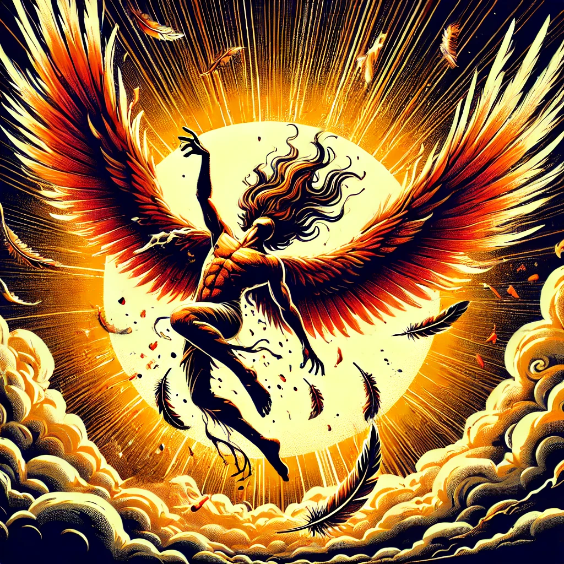
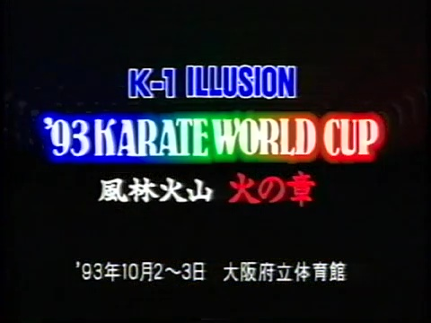
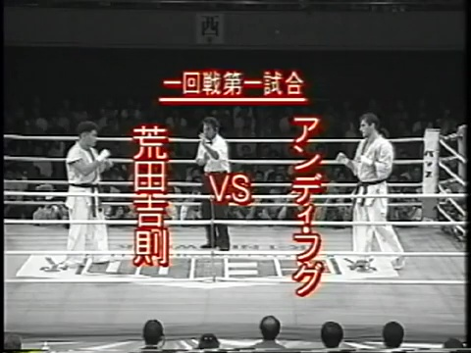
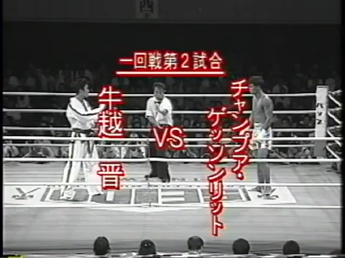
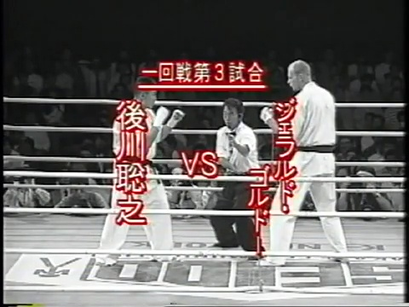
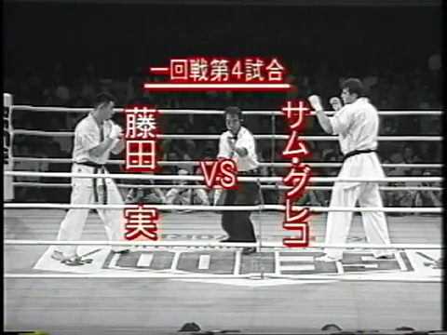
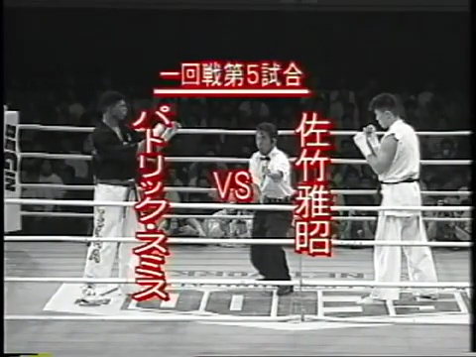
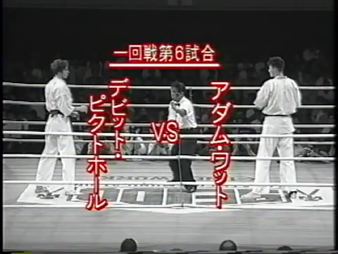
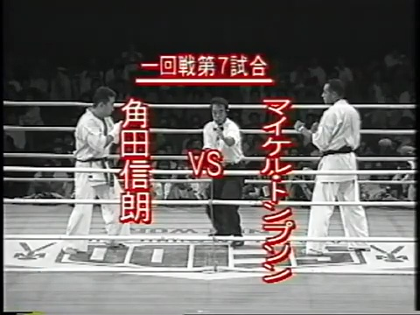
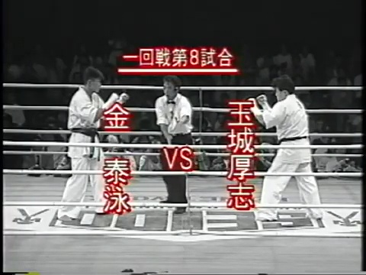
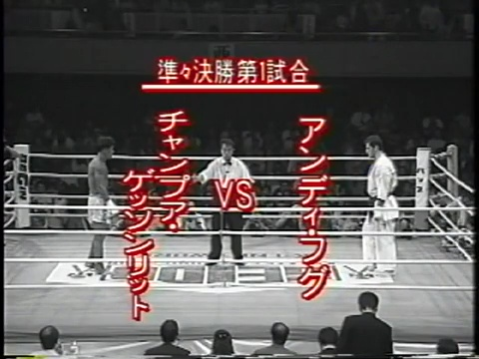
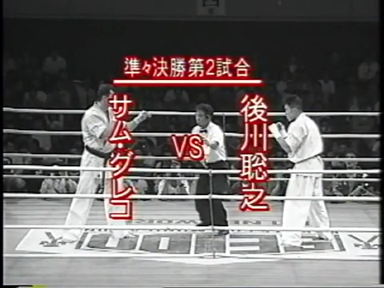
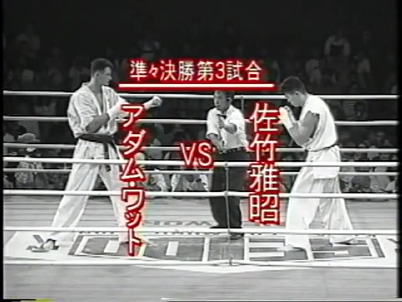
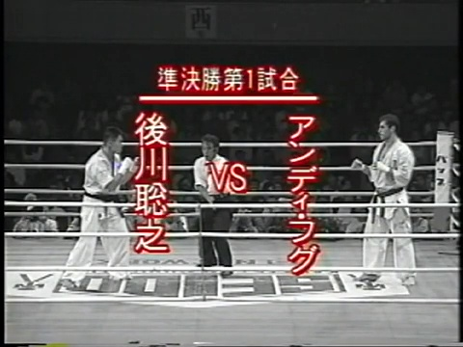
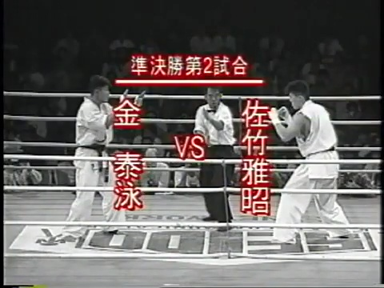
Kakutogi Road: The Complete History of MMA Vol. 81 "The Flight of Icarus: A Grift Too Close to the Sun"
"Don't fly too low, my son, or the dampness will clog your wings. And don't fly too high, or the sun's heat will melt them."
Daedalus’ warning to his reckless son, Icarus, is one of history’s oldest lessons in hubris, an enduring reminder of the perils that come with overreaching ambition. Unfortunately for Kazuyoshi Ishii, today's subject, it seems his classical studies were woefully lacking. Ignoring the consequences of flying too close to the sun, Ishii would bet everything on a grift both audacious and ambitious—and in doing so, he charted his own inevitable fall.
The dates are October 2nd and 3rd, 1993, and what we’re about to witness is the apex of Ishii’s ongoing con. At this moment, he’s betting his entire reputation—and, more dangerously, the public’s trust—that he controls the premier kickboxing talent in Japan. His instrument of deception? None other than his plucky, ever-obedient lieutenant, Masaaki Satake. We last left this duo just a month ago when Ishii pulled off what seemed impossible: stretching his grift to new heights by pitting Satake against the dangerous, yet not invincible, Stan "The Man" Longinidis.
It was a battle that should have spelled disaster. Satake, having previously bungled an easy win at the inaugural K-1 King of Kings tournament earlier in the year, had nearly brought the whole operation crashing down. But against all odds, Satake pulled off the upset, defeating Longinidis and saving not just his ego, but Ishii’s grand scheme. That victory wasn’t just a fluke; it was a lifeline. A temporary reprieve for a man on the edge of losing everything. It allowed Ishii to breathe for another day, to prolong his con, and to dangle the illusion of dominance just a little longer in front of the eager, paying Japanese public.
But like all flights that dance too close to the sun, the wax begins to melt. Ishii's grand deception, much like Icarus' wings, now operates on borrowed time. The inevitable crash looms, a fiery descent back to reality. Yet, in this fleeting moment, we witness the zenith of Ishii's audacious scheme. It's a paradoxical triumph, a testament to his ability to defy gravity, if only temporarily. This success, however fleeting, likely fueled his hubris, driving him deeper into the blinding radiance of his own ambition, inching closer to the sun's unforgiving heat.
Over the next two days, Satake would secure victories against an impressive array of kickboxing talent, including the future UFC standout and karate virtuoso, Patrick Smith, and the legendary Andy Hug. These wins, while not without controversy, underscore Satake's undeniable skill and validate, to some extent, Ishii's gamble. Satake, in these early days, possessed the raw talent to propel the K-1 brand forward, offering a glimmer of legitimacy to Ishii's grand illusion. Though the grift was destined to shatter, Satake's abilities provided the initial momentum, a spark that ignited K-1's ascent.
But the sun's heat is relentless. Ishii's wings, weakened by ambition and deceit, flutter precariously. The fall, when it comes, will be swift and spectacular.
ML: There's a school of thought that suggests Ishii was actually the first genius real fighting promoter. He got people in the seats initially by pretending Masaaki Satake was a thing. Satake may not have been able to carry the promotion on his shoulders yet like Maeda or Takada were, but there was more than enough interest in him to get K-1 off the ground. When Maeda went down with knee surgery, RINGS was barely able to tread water. They didn't have another native star, and failed to either create one or elevate any of the foreigners to a level that was much beyond what they were already at when Maeda was healthy. On the other hand, Ishii may not have been able to promote the traditional Japanese dominant promotion that we saw with pro wrestling for years were the foreigners were oversized foils, but he drew better than RINGS in 1993 with Satake, and was rather quickly able to create enough huge stars in guys like Andy hug, Ernesto Hoost, and Peter Aerts that the popularity of the league actually increased despite his puppet Satake being exposed as a 3rd tier fighter, and no other natives ever rising up to replace him. Imagine if UWF-I would have been able to pivot off Takada when his cowardice was exposed rather than selling out to New Japan for some quick cash that merely cemented their irrelevance. Ishii may not have started with the greatest vision, more importantly, he didn't stubbornly cling to it forever.
K-1 ILLUSION As Daring as Fire Fire Chapter '93 Karate World Cup 10-2-93 + 10-3-93
[JK] Narration: “Andy Hug: The first foreigner to win the Karate World Cup last year; the defending champion. He aims to transition to gloved fighting [kickboxing]. For this purpose, he hopes to win the championship for the second time in his final karate tournament.
Masaaki Satake: He won the WKA World Super Heavyweight Title by beating Australian star, Stan the Man, with a large difference in points. Together with the UKF World Heavyweight Title, he now has two world titles. With the aim to win back the World Cup title that he lost to Any Hug; he will again enter this split karate tournament after two years.
Nobuaki Kakuda: Ever since the first Seidokaikan All Japan championships held in 1982, he has been entering the tournament each year, 12 years in a row. He will stake his retirement to take revenge on Michael Thompson to whom he lost last June in a mere six seconds.
This battle is for the title of the world’s greatest in karate: ’93 Karate World Cup. The battle of dreams is about to start!”
Osaka Prefectural Gymnasium 1993 October 2~3
Oct 2: Qualifying matches were held among 37 fighters, including Seidokaikan fighters, Atsushi Tamaki, Keisuke Nakagawa, Eiji Matsumoto, and Yoshinori Arata; and Gōzen Morita from Shidokan, Fred McCord who is the USA taekwondo champion. Arata of the Kyoto branch of Seidokaikan won A block; Nakagawa of Seidokaikan headquarters, aiming for revenge against Sam Greco, won B block; Tamaki of the headquarters, who won the Satojuku karate championship, won C block; technician Matsumoto of the Hiroshima branch, who took 3rd place in the ’93 point & KO All Japan championship won D block.

Highlights of Yoshinori Arata vs. Keisuke Nakagawa (for A+B blocks) & Atsushi Tamaki vs. Eiji Matsumoto (for C+D blocks) qualifying matches: Arata wins the A+B blocks by decision. Arata’s postfight comment: “Well, I did what I had to do, and that was the result. Yeah, well, I’ll do my best tomorrow.” Tamaki wins the C+D blocks by decision. Tamaki’s postfight comments: “Well, I know my friend Kin is doing well, so I plan to keep also advancing without losing.”
Explanation of split Karate rules: 3 mins. time limit; if draw an extra 2 min. round, and if still a draw another extra 2 mins round. If the 2nd extra round leads to another draw, the decision will be given to the lighter fighter if the weight difference is over 10 kg. If there is no difference in weight of over 10kgs, an extra 2 mins round with gloves, allowing punches to the head, will be held. If that results in a draw, another 2 min extra round. If the gloved match still results in a draw, the winner will be decided by the number of tiles broken. If they both break the same number of tiles, the lighter fighter will be declared the winner. Knockdown of opponent: for over 3 seconds is one full point [ippon] (= win); and under 3 seconds is half point [waza-ari]. Strikes to the face or head with the fist or elbow are not permitted. Grabs are permitted for under 3 seconds; this means throws are allowed even if they don’t gain you points.
Oct 3: main tournament:
Kakuda’s joking comment to the camera in the dressing room: “Look at them scary dudes, they all have solid bodies. They must do karate…”
Opening ceremony: entrance of all fighters: Yoshinori Arata (172cm, 84kg; Seidokaikan Kyoto branch); Atsushi Tamaki (170cm, 85kg; Seidokaikan headquarters); Shin Ushikoshi (175cm, 75kg; Japan International Taekwondo Federation); Gerard Gordeau (198cm, 100kg; Netherlands); Minoru Fujita (176cm, 77kg; Seidokaikan headquarters); Sam Greco (188cm, 101kg; Australia); David Pickthall (181cm, 77kg; England); Patrick Smith (188cm, 97kg; USA); Changpuek Kiatsongrit (173cm, 75kg; muaythai, Thailand); Nobuaki Kakuda (174cm, 90kg; Seidokaikan headquarters); Michael Thompson (180cm, 86kg; England); Adam Watt (192cm, 85kg; Seidokaikan headquarters); Taiei Kin (180cm, 74.5kg; Seidokaikan headquarters); Toshiyuki Atokawa (175cm, 81kg; Seidokaikan headquarters); Masaaki Satake (185cm, 93kg; Seidokaikan headquarters); Andy Hug (180cm, 91kg; Switzerland). Declaration by Andy Hug representing all fighters that they will fight honestly with sportsmanship, etc. [This is a ritual usually done in sporting tournaments in Japan]
'93 Karate World Cup
1st Round:
Andy Hug vs. Yoshinori Arata 2:09
After a quick rundown of highlights, introductions, and a brief explanation of the rules, the action cuts to the perfect man to set the tone for the event: the legendary Andy Hug. From the moment the bell rang, it was clear Arata was walking into a storm. He barely had time to blink before Hug spun with laser precision, planting a devastating kick square into Arata’s midsection. That was probably not the welcome Arata had in mind. From there, Arata spent the rest of the fight scrambling to fend off a relentless onslaught of kicks, trying to stay in the game, but the writing was already on the wall. And then, as if choreographed for maximum impact, Hug launched a high-kick straight to Arata’s face, dropping him like a stone. It was clinical. It was brutal. It was pure Andy Hug.
The highlight? Aside from Hug’s perfect technique, it might’ve been the understated "Andi" stitched into the back of his gi—looking like something his grandmother lovingly sewed on. A charming contrast to today’s modern jiu-jitsu gis, plastered with sponsor logos like walking billboards. Hug's simple, humble appearance stood out as a reminder of martial arts purity.
A short fight, but one that left no doubt: Hug was in a class of his own.
ML: Hug has a big reach advantage, but his style is very much based upon moving backwards so he can exploit it by either stepping in with a powerful body or axe kick or intercept Arata when he tries to close distance so he can actually land something. That never really happened for Arata. Eventually, Hug stepped in with two body punches to drop Arata's hands, then came over the top with a high kick for the knockout.
Shin Ushikoshi vs. Changpuek Kiatsongrit 1R
The ultimate battle of Taekwondo vs. Muay Thai!
First, let's raise a glass to Changpuek Kiatsongrit, the Muay Thai warrior seemingly ready to rumble in Japan at a moment's notice. Kickboxing, UWF, even a back-alley dice game – Changpuek's game for anything the Land of the Rising Sun throws his way. And tonight, he kicks things off in spectacular fashion, snatching Ushikoshi's opening kick out of the air and schooling him like an errant pupil. Ushikoshi, fleet-footed and agile, dances around the ring, showcasing the speed and footwork that Taekwondo is known for. But as the fight closes in, a familiar story unfolds. Like many pure TKD stylists of this era, Ushikoshi struggles in the clinch, his arsenal lacking the tools to navigate the close-quarters combat Muay Thai thrives in.
From a distance, Ushikoshi unleashes a flurry of kicks, but Changpuek, with his methodical advance and devastating power, closes the gap, leaving his opponent with nowhere to run. Changpuek's kicks land with the force of sledgehammers, each one a testament to his years of experience and the brutal efficiency of Muay Thai. Ushikoshi's athleticism hints at untapped potential. With more experience and a broader skillset, he might have been a formidable force. But tonight, he's a stark reminder that pure Taekwondo, while beautiful and dynamic, faces an uphill battle in the unforgiving world of combat sports.
The final bell tolls, and the decision is clear. Changpuek's power and experience prevail. It's a victory for Muay Thai, but also a poignant lesson for all those who dare to enter the ring with a limited arsenal. The Kakutogi Road is paved with broken dreams, and tonight, Ushikoshi adds his name to the list.
ML: It's interesting to see this fight right after the Hug fight because Shin is also trying to move to create distance then come forward with a kick. The problem is his kicks lack the speed, directness, and accuracy of Hug's. Kiatsongrit is able to time Shin and intercept him with quicker and more direct counter strikes. He also walks Shin down, unafraid of anything shin can throw at him. Again, this is a very one-sided fight, with Taekwondo proving to be all flash and little substance.
Toshiyuki Atokawa vs. Gerard Gordeau 1R
One month before Gordeau’s infamous American debut at UFC 1, he makes a pit stop in Japan, doing what he does best: breaking every rule in the book. Atokawa, fiery and determined as ever, clearly rubbed Gordeau the wrong way—and when that happens, you can bet Gordeau will seize any opportunity to cheat. This was a fight Gordeau should have won—and likely would have—if he could do anything other than what he’s not supposed to. From the start, it was less of a fight and more of a highlight reel of illegal moves. Atokawa, to his credit, fought valiantly through the chaos, but there’s only so much you can do when your opponent seems more focused on bending the rules than actually fighting.
In the end, the inevitable disqualification came down, putting an end to the madness. Gordeau, with all his skill, threw away a win he could’ve easily claimed. Another day, another broken rulebook.
ML: Gordeau gave his typical shameful performance, cheating from the opening bell to the closing bell. He's just using his hands to the face to push Atokawa back into the ropes, sort of a shady version of sumo. Once he gets him there, he seems intent to use his elbow on Atokawa's throat for a sort of remedial forearm choke, which of course isn't legal. This actually could have been a lot worse, as somehow Gordeau managed to keep his fingers out of Atokawa's eyes most of the time. Gordeau had a big size advantage, and was able to push Atokawa around with ease, but he was so intent on bullying him that most of his offense was neither illegal, nor that effective in a kickboxing match. Since Gordeau wasn't credited for his cheating, Atokawa wound up winning a unanimous decision despite barely landing a blow. This was all around embarrassing.
Sam Greco vs. Minoru Fujita 1R
Australian sensation Sam Greco returns to the ring, and this time, he’s here to dismantle Minoru Fujita. Tough as nails, Fujita absorbed an ungodly amount of punishment, but it was like trying to stop a freight train. Greco’s inside game was relentless, hammering Fujita with a brutal barrage of strikes. Fujita showed heart, no doubt, but there was little he could do to slow Greco’s onslaught. It wasn’t just a win for Greco—it was a demolition.
ML: Greco was a buzzsaw here, just blistering the body with a series of blows then finishing with a kick or knee. Fujita finally landed a few kicks at the end because Greco knew he'd done more than enough and decided to conserve his energy.
Masaaki Satake vs. Patrick Smith 1:16
Enter Patrick Smith, a future MMA journeyman and UFC 1 veteran, known as much for his explosive power as for his volatile temperament. A fantastic hammer in search of a nail, Smith possessed the raw potential for greatness, but his Achilles’ heel was always adversity—whenever it struck, he faltered. From the opening bell, Smith unleashed a whirlwind of fists and fury upon Satake. His aggression was unbridled, and Satake, caught off guard, found himself on the back foot, struggling to weather the storm.
But just as Smith seemed to be in control, a cruel twist of fate unfolded. After a thunderous punch to Satake's midsection, a sickening crack echoed through the ring—Smith’s hand had betrayed him. His momentum halted in an instant, and the warrior’s spirit, so fierce just moments before, crumbled under the weight of the injury. Instead of rallying or demanding to continue, he wilted, collapsing onto the canvas as pain coursed through him. Ishii, ever the opportunist, seized the moment, perhaps with a bit too much eagerness, waving off the fight as Smith remained on the mat. Satake, spared further punishment, stood victorious, though the victory felt bittersweet.
It was a fight that tantalized with a glimpse of Smith’s potential, only to be cut short by a cruel stroke of bad luck. Once again, Smith fell victim to his own volatility, undone not by his opponent, but by the fragility of his body. For Ishii, it was another bullet dodged, another opportunity to prolong his grand illusion. But the cracks in his facade were beginning to show, and the house of cards he had so carefully constructed seemed poised to teeter on the edge of collapse.
ML: Unlike in the Grand Prix, Satake actually had a tough road here, facing one of the tougher first round opponents, if not the toughest. Smith looked amazing here. He had so much more speed and explosion than Satake. Smith was running away with the fight when he seemingly broke his right hand on Satake's chest. Satake landed a body shot back, so he tried to pretend he actually did something to put Smith down, and the fight was quickly called by the ref, who conveniently was grifter Ishii, when Smith was busy shaking his hand out. It's unfortunate on multiple fronts, including that this was the most exciting fight thusfar.
Adam Watt vs. David Pickthall 1R
Adam Watt has been one of the standouts of 1993, even in his losses to high-profile opponents, and today was no different. From the opening bell, Watt took control, dictating the pace and overwhelming Pickthall with a relentless barrage of devastating knees that would have crippled a lesser man. Pickthall showed heart, battling to the end, but it was clear from early on that he was out of his league. Despite his best efforts, he simply couldn’t match Watt’s power or precision. With this dominant performance, Watt continues to solidify his reputation as a rising force in K-1/kickboxing.
ML: A much more intense fight then we've generally been seeing here. As with most of these fights, the fighter with the notable size advantage just had so many more options. In Watt's case, he used his height to leverage clinch knees.
Michael Thompson vs. Nobuaki Kakuda 1:40
The stage is set for a rematch laden with emotion and consequence. Four months prior, Nobuaki Kakuda, the proud ambassador of Seidokaikan, suffered a crushing defeat at the hands of Michael Thompson. The loss, swift and decisive, left a bitter taste in Kakuda's mouth, a wound to his warrior's pride. Tonight, under the bright lights of the Osaka arena, Kakuda seeks redemption. He carries the weight of Seidokaikan on his shoulders, his every move a reflection of their legacy. But Thompson, a rising star with a penchant for the spectacular, stands in his way.
The bell rings, and the two warriors clash. Kakuda, fueled by determination, pushes forward, seeking to impose his will. But Thompson, ever the opportunist, waits for his opening. It comes in a flash, a spinning high kick that crashes into Kakuda's head like a thunderbolt. The proud warrior crumples, his dreams of redemption shattered in an instant. The crowd falls silent, a collective gasp echoing through the arena. Kakuda, once again, has been humbled, his fighting spirit momentarily extinguished. But even in defeat, his warrior's heart shines through. In the quiet moments after the fight, his words reveal the depth of his character: "I'm disappointed that I lost... but, at least today, I'd like to tell myself, 'good job, you did well.'"
This second loss marks a turning point in Kakuda's career. The dream of championship glory fades, replaced by a new role as an ambassador and elder statesman of K-1. He becomes a beloved figure, his fighting spirit and unwavering dedication earning the respect of fans and fellow fighters alike. Though his time as a top contender may be over, Kakuda's legacy lives on. He remains a symbol of the warrior's code, a reminder that true strength lies not just in victory, but in the courage to face adversity and the grace to accept defeat. His journey, though marked by setbacks, is a testament to the enduring power of the human spirit.
ML: Kakuda went out on his shield tonight. He did what he had to try to overcome his size disadvantage, closing the distance aggressively and trying to work on the inside. The problem is Thompson knew what Kakuda had to do also, and was able to time him with two spinning high kicks. The first one didn't connect fully, but the second one Kakuda was almost stretchered out from. The first storm weathered by Ishii was surviving the loss of his #2 native, Kakuda, who retired when he failed to avenge his loss to Thompson here. Kakuda lacked the size to dominate openweight kickboxing tournaments, but his heart and determination always brought him admiration from both the fans and his peers, and he was a backstage leader, having been captain of his university karate club. Kakuda would return 2 years later, knocking out the infamous rapist Joe Son in his kickboxing debut on 7/16/95.
]
Taiei Kin vs. Atsushi Tamaki 1R
The Forgotten Hero: A Victim of the Grift
Of all the fighters caught in the tangled web of Ishii's ambition, Taiei Kin arguably suffered the most. His story is a testament to the injustice and heartbreak that can fester beneath the surface of a carefully constructed illusion. Rewind to January 1992, the culmination of a grueling 57-man kickboxing tournament. Kin, after a hard-fought battle, emerges victorious against Masaaki Satake, the decision clear and undisputed. But then, in a moment that would forever alter Kin's trajectory, Ishii, the puppet master, steps into the ring. With a wave of his hand, he overturns the judges' verdict, ordering an unprecedented extra round. Satake, fueled by this unexpected lifeline, capitalizes, snatching victory from the jaws of defeat.
Kin's moment in the sun, his chance to break free from the shadows, is cruelly extinguished. From that point on, he becomes a pawn in Ishii's game, a formidable opponent used to build up others, his own aspirations sidelined. Tonight, against Atsushi Tamaki, Kin fights with a fire born of frustration and a hunger for recognition. He's a man possessed, relentlessly pursuing victory with a ferocity that belies his gentle demeanor. He clinches, knees, and grinds Tamaki into submission, a testament to his unyielding spirit.
It's a bittersweet victory, a reminder of what could have been. Kin, the forgotten hero, the victim of a grift that robbed him of his rightful glory, continues to fight, not for championships or accolades, but for the simple satisfaction of proving his worth. His story is a cautionary tale, a reminder that even in the glamorous world of K-1, darkness lurks beneath the surface, and justice is not always served.
ML: This was all inside fighting, often holding on to each other's gi's. Kin was much more effective at this than Tamaki, using it for knees to the midsection rather than the outside thigh kicks of Tamaki.
Quarterfinals:
Andy Hug vs. Changpuek Kiatsongrit [Karate vs Muay Thai] 1R
This fight was the undisputed highlight of the evening, a mesmerizing collision of two distinct martial arts philosophies embodied by two warriors at the peak of their powers. Andy Hug, the karate virtuoso, steps into uncharted territory, facing a Muay Thai specialist for the first time in his illustrious career. Changpuek Kiatsongrit, the Thai wrecking ball, finds himself in an equally unfamiliar landscape, navigating the unfamiliar terrain of karate rules, where punches to the face are strictly forbidden.
It's a testament to Kiatsongrit's adaptability that he even remembers which sport he's playing, let alone the nuances of its rule set. This man has fought in so many bizarre matchups in Japan that it's a wonder he doesn't accidentally break out into a sumo stomp or a pro-wrestling clothesline mid-fight. But tonight, it's karate, and Kiatsongrit, despite his Muay Thai instincts screaming for a full-frontal assault, adapts remarkably well. Hug, the seasoned veteran in this karate format, appears momentarily flustered, unsure how to engage this unorthodox opponent who dances on the edge of the rules.
Changpuek, sensing an opportunity, presses the attack, his kicks and knees a blur of controlled aggression. But his Muay Thai instincts betray him, his fists repeatedly finding their way to Hug's face, each infraction a splash of cold water on his fiery momentum. It's a frustrating dance, a battle of wills waged between the ropes and the rulebook. The fight hangs in the balance, a testament to the skill and determination of both warriors. It seems destined for extra rounds, a fitting conclusion to this epic clash. But Kiatsongrit's repeated fouls tip the scales, the accumulated penalties proving too much to overcome.
Hug emerges victorious, but it's a win tinged with a sense of unfinished business. The crowd, buzzing with excitement, yearns for a rematch, a chance to witness these two titans clash again, this time on a level playing field. For now, the karateka reigns supreme, but the Muay Thai warrior has left an indelible mark, a reminder that in the ever-evolving world of combat sports, adaptability and respect for the rules are as crucial as power and precision.
ML: Kiatsongrit didn't know how to deal with Hug's movement. He was too stationary here, and allowing Hug to dictate is never a good idea. Hug is one of the only fighters who can win by consistently stepping forward with a kick, but he has enough variety and disguise you don't know which kick to defend, and he's so flexible he can essentially reach forward more with his leg to connect to the opponent's face. This was an entertaining fight, the most satisfying on the show given the unfortunate finish of Smith vs. Satake, with Hug's dynamism on full display. The karate rules were unfortunate for Kiatsongrit's ability to compete because his best answer was the illegal punch to the face.
Sam Greco vs. Toshiyuki Atokawa 3R
This bout was a fascinating look at how combat sports handle weight differences between fighters. After two overtime rounds of cautious exchanges, neither man managed to pull ahead decisively. Instead of pushing for another round, the judges awarded the victory to Atokawa, citing his lower weight as the deciding factor. It was an unusual, almost anticlimactic conclusion, but one that fit the methodical pace of the fight. The result makes me wonder about its potential applications in modern combat sports—though, knowing athletic commissions, it’s safe to say they’re not eager to embrace any radical changes. Throughout the fight, both Greco and Atokawa seemed more concerned with avoiding risks than landing anything decisive. They kept each other at bay with measured strikes, but almost everything was blocked or absorbed, with neither fighter willing to fully commit to offense.
As the overtime rounds dragged on, it became clear that neither man was going to break through. Atokawa, perhaps more comfortable in the slower pace, ultimately got the nod thanks to the weight difference. In the end, his win felt deserved, even if it was earned more through cautious survival than aggressive dominance. While the fight didn’t deliver fireworks, it did offer a glimpse into the complexities of navigating weight disparities—a factor that can shift the balance of a match even when both fighters seem evenly matched in skill. Atokawa walks away with the victory, and Greco, despite his size advantage, is left wondering how the scales tipped out of his favor.
ML: Atokawa fought smart, staying on the outside, where he was effective circling and landing low kicks. He was giving up a lot of reach, but the previous fight clearly showed that fighting on the inside with Greco is a bad idea. Greco wasn't able to throw many body punches here, and that's arguably his best weapon. Atokawa started standing in front of Greco too much in the extra round, and trading kick for kick with his more powerful opponent wasn't a good idea. I thought Greco won this round, but perhaps just standing in the center all fight didn't do him any favors. He certainly had none of the energy and aggression he displayed in the 1st two minutes of the opening round. Greco was definitely too passive in the 2nd overtime. Atokawa moved more again in this round, which was smart because now he didn't have to win the fight per se, he just had to be even enough to survive so he'd win via weight discrepancy. This wasn't one of the better matches since Greco basically beat himself due to lack of energy and a poor gameplan. Credit to Atokawa for showing a smaller fighter could actually break through here though.
Masaaki Satake vs. Adam Watt 3R
It wouldn’t be early '90s K-1 without a dash of the dubious and a sprinkle of the suspicious. The bout between Masaaki Satake and Adam Watt had all the makings of a draw, with both fighters locked in a tense stalemate. Neither man seemed willing to fully commit, trading cautious blows but never quite pulling ahead. By all accounts, the fight was headed for an extra round—perhaps even a Double Dare-style physical challenge. But instead of letting the fighters decide the outcome, the judges intervened, handing Satake the win in a move that defied all logic. No explanation, no reasoning—just an inexplicable decision that reeked of favoritism. It was as if the judges, fearing Ishii’s wrath, handed the victory to Satake on a silver platter, leaving Watt and the audience scratching their heads.
The stench of corruption hung in the air, casting a shadow over what should have been a thrilling contest. It was a stark reminder that even in the fast-growing world of K-1, the sport wasn’t immune to the whims of powerful figures like Ishii. Satake, despite his undeniable talent, was caught in the web of his mentor’s ambition. And what’s worse—he likely didn’t even know it. Satake had real skill, no doubt about it. But instead of letting his talent speak for itself, his victories often felt orchestrated, his path smoothed by shady decisions and backroom deals. Perhaps, at this stage in his career, he genuinely believed the hype, unaware that he was a pawn in a larger game, dancing to the strings pulled by Ishii.
This fight between Satake and Watt serves as a cautionary tale—where strength and skill are meant to reign supreme, the human element, with all its flaws, can cast a long shadow. The pursuit of glory, especially when influenced by those with ulterior motives, often leads to murky waters, where the line between victory and manipulation blurs.
ML: One of Satake's big problems is that even the taller fighters are much quicker and more athletic. Watt was able to outland Satake badly not purely on reach, but through his ability to outmanuever him to score while maintaining distance. Satake stalked, but barely threw anything because he was looking to punch, and Watt would back him with a kick before he got close enough. Satake got more aggressive in the second half of the round, and if he could close the distance quickly enough to grab Watt's gi, he could actually get a couple punches in. This was an easy win for Watt, but the judges called for an extra round. Now Watt didn't know what he had to do because he couldn't defeat Satake much more convincingly in the style he was using then he already did. Watt didn't move as much in this round, so it was more competitive. Still, Satake didn't have much offense beyond some little right hooks to the side while holding the key with his left hand. This round was somewhat even in its uneventfulness. Satake added a jumping knee out of the clinch in the third, but after the 1st one landed well, he was either missing or grazing. Watt was tired, but while he moved less, he became more aggressive offensively. Satake looked so bland and one dimensional here, showing no dynamism. Again, he lost the round, doing nothing of note beyond the initial knee, while Watt backed him with kicks, and even landed better punches on the inside. Magically though, Satake was now awarded the decision. What a fraud!
Taiei Kin vs. Michael Thompson 3R
draw; extra-round: draw; extra-extra round: draw; decision goes to Kin due to weight difference of over 10kgs.
ML: This was the first fight where both men seemed to want to move, rather than one using footwork and the other wanting to fight toe to toe on the inside. Thompson did a much better job of actually landing while he was circling then Kin did. Kin shifted to trying to fight on the inside more in the two extra rounds, which worked a lot better for him. These portions were basically even, shot for shot. Thompson won the distance fighting though. I would say Thompson won the first and third round, while the second was definitely not a round they were going to give to anybody. Thompson didn't win any round convincingly, but he was clearly the more successful of the two. He was not happy when Kin won via the weight rule. This fight was average, at best.
Semifinals:
Andy Hug vs. Toshiyuki Atokawa 2R
Atokawa wisely tried to turn this into a phonebooth-style brawl, keeping the fight in close quarters, which might have worked against a lesser fighter. But Andy Hug isn’t your average mortal—he seemingly has the ability to fire off whatever creative kick he wishes, moving in any direction he pleases. Despite these near-Thanos-level powers, Hug didn’t have an easy time putting away the crafty Atokawa. Atokawa’s defense and determination kept Hug on his toes, dragging the fight into an extra round. It was in that final round that Hug finally pulled ahead, earning the decision. A good fight that showcased Hug’s dynamic striking and just how tough Atokawa really is.
ML: The judges are either giving the fighters more leeway in these later rounds of the tournament, or under orders not to score of the fight against the Seidokaikan fighter unless they absolutely have to. Hug didn't have nearly as much success here, but Atokawa was fighting in purely defensive mode, looking to deflect or catch the first shot, then tie Andy up. Atokawa barely threw any strikes, but Hug wasn't catching him cleanly. Hug had much less success in the extra round than in the 1st, but now they awarded him the decision. Definitely not one of Hug's more interesting matches.

Masaaki Satake vs. Taiei Kin R2 0:49
Watching this fight evokes a bittersweet symphony of emotions. On one hand, it’s a testament to Satake’s undeniable talent, proof that even amidst Ishii’s manipulative puppetry, there existed a spark of genuine skill. On the other hand, it’s a painful echo of the injustice that robbed Taiei Kin of his rightful place in the spotlight. Kin, once a rising star, had his moment cruelly stolen at the inaugural Towa Cup in 1992, his path to glory derailed by Ishii’s heartless schemes. Tonight, he faces Satake—a fighter whose victories often come with an asterisk of favoritism. This is more than just a bout; it’s a battle weighted with history, a clash between a man seeking redemption and another caught in the web of his mentor’s ambition.
From the outset, Satake’s physical advantages are clear. He towers over Kin, every movement radiating power and confidence. But Kin, undeterred, fights with the heart of a lion, unleashing a flurry of strikes in a desperate attempt to overcome the odds. His resilience is palpable, but it’s not enough. Satake, combining skill with opportunity, overwhelms Kin in the extra round, his relentless pressure culminating in a brief but thunderous knockout. Kin, ever the warrior, rises to his feet almost immediately, but the damage is done. The crowd erupts, their cheers a blend of admiration for Satake’s performance and a lingering sense of unease. It’s a victory, yes, but one tainted by the knowledge that the playing field was far from level. Satake, the unwitting beneficiary of Ishii’s grand scheme, basks in the adulation, blissfully unaware of the whispers and doubts that swirl around him.
For Kin, this loss is another chapter in a career plagued by injustice. His path to glory was blocked, not by lack of talent, but by forces outside his control. Yet, despite the setback, Kin remains unbroken, his fighting spirit as strong as ever. He continues to fight—not for championships or accolades—but for the sheer love of the sport and the belief that one day, the truth will prevail. This fight is a microcosm of early K-1, a world where ambition, skill, and manipulation often collided. It reminds us that the pursuit of glory can be a treacherous path, one fraught with obstacles both seen and unseen. And for Taiei Kin, it’s a poignant chapter in a story of resilience—a testament to the unbreakable human spirit in the face of adversity.
ML: Satake was much more aggressive here, fighting against opponent who was giving up 41 pounds. Satake clearly didn't believe Kin could hurt him. He just plodded forward, and was now throwing a bunch of kicks, whereas he threw almost none in the previous fight against Watt. This was a fight where they would have been justified awarding the decision to Satake after the first. It didn't much matter since Satake finished him with a knee early in the extra round anyway.
[JK] Public announcement from Kakuda in the ring: “In the past, every time I’ve faced my limits both spiritually and physically, I continued to fight with your support and the support of Kancho Ishii. Satake, Atokawa, and Kin have all grown and become strong. I have been looking on as they developed and feel that I have accomplished my role. I decided that at the end of this tournament I will retire from karate competition. Thank you today for all of your support!”
Announcer: “Seidokaikan Kancho Ishii will present congratulatory flowers to Kakuda, who has had a long career of fighting all these years….. Let’s give Kakuda a big round of applause!”
Final: Andy Hug vs. Masaaki Satake 5R
The Grift's Grand Finale: A Tile-Breaking Farce
And so we arrive at the climax of Ishii's grand illusion, the night where his carefully woven web of manipulation reached its apex. It was a spectacle that showcased both the brilliance of K-1’s athletes and the murky depths of its backstage politics—a night forever etched into the lore of the sport. Andy Hug, the rising superstar, stood across from Masaaki Satake, Ishii’s chosen one. What followed was a clash of titans, an intense battle that stretched through four grueling rounds, with neither fighter willing to concede. The crowd, electrified by the drama and intensity, roared with every exchange, fully immersed in the spectacle.
But after multiple rounds of overtime—draw, extra round, extra-extra round—neither Hug nor Satake could land a decisive blow. The judges, trapped in indecision, opted for the most bizarre of resolutions: a tile-breaking contest. Yes, after all the sweat, the strikes, and the near-knockouts, this epic battle would be settled not by fists or kicks, but by who could smash the most inanimate objects. Satake, perhaps buoyed by the invisible hand of favoritism, broke nine tiles to Hug’s eight. The crowd, a mixture of bewilderment and resignation, watched as the night’s climactic fight was reduced to a contest better suited for a dojo demonstration. In that absurd moment, Ishii’s grand scheme reached its zenith, with Satake emerging victorious—but in a manner that felt hollow, like a magician’s final trick exposed for all to see.
Hug, in the eyes of many, was the true champion of the night. His aggression, his skill, and his heart had shone through in every round. But the shadow of manipulation, the hand of Ishii, denied him his rightful glory. One tile—the difference between victory and defeat—bruised more than just Hug’s ego; it was a bitter reminder of how tightly K-1’s fate was wrapped in the whims of those behind the scenes. For Satake, this was the pinnacle of his career. A night of fleeting glory that would never be replicated, as his performances from this point on failed to live up to the hype Ishii had so carefully crafted. He had some decent moments in Pride FC and a few other fights, but this was the peak—a peak built on shaky ground.
The absurdity of ending such an intense fight with a tile-breaking contest leaves a lingering taste of disappointment. Sure, this was a nod to the traditions of Kyokushin karate, where breaking tiles held a certain weight, but as the deciding factor for a clash between two elite fighters, it felt like a farce. As entertaining as the night was, it was also a reminder of how close K-1’s early years were to the spectacle of pro wrestling. Ishii’s Icarus-like ambition, his drive to mold reality to fit his narrative, would ultimately lead to his downfall. Yet amid the manipulation and favoritism, fighters like Andy Hug and Taiei Kin persevered. They represented the essence of K-1’s promise—fighters with heart, grit, and skill, navigating a landscape that often favored the politics of power over true merit. Even as victims of the system, they became symbols of resilience, their fighting spirit undimmed by the forces working against them.
ML: The farce of all farces. This fight was totally one way traffic. Hug clearly won every round by virtue of being the only one landing, yet time and time again he was denied the decision. Hug is 100 times the athlete of Satake. He wasn't nearly as fast and dynamic as he was at the start of the night, as his style obviously expends a ton more energy, but he was the only one moving. Hug didn't fight on the inside the entire tournament. As long as he fought on the outside, Satake was never going to do anything to Andy, especially now that Satake was back to only trying to punch. So why on earth was Andy suddenly trying to work the clinch game against his slowest and least mobile opponent? He just willingly deviated from his style of exiting after the kick that we'd seen all fight to one of clinching after the kick that gave Satake his only opportunity to actually do anything even though it never resulted in anything. Granted, Hug still had the advantage in the clinch. Hug did more on the inside than Satake for sure, but it was like 55% of nothing to 45% of nothing compared to 100% of something to a big fat zero. It was clearly the first strike outside that was distinguishing Hug. Round after round, Hug would land a kick on the entry, then struggle on the inside due to his own stubbornness. I suppose this could have given the illusion that Satake was actually doing something to the people with the rose-colored Satake glasses on, if we want to give them the benefit of the doubt, which they already don't deserve after the Watt travesty. Round after round of Satake barely landing didn't do anything to dissuade them. What's worse is the few times Satake did land, it was all what I'd call stand and pound, which is basically these closed quarters little arm shots to the ribs that are similar to ground strikes just meant to annoy, hopefully get the opponent to make a mistake, or at least keep the ref from standing them up. Anyway, Hug's biggest problem here beyond widespread corruption is that he barely landed a shot on the inside either, and wasted a lot of time doing nothing when you could have been continuing to score at distance. Hug was certainly looking for the decision after clearly winning the first two rounds, but he wasn't Ishii's chosen one. This pattern continued, with Andy showing great restraint in not hoping to the outside and strangling the judges. Satake never did anything different, he just allowed Hug to dictate the fight, and Hug allowed Satake to be somewhat competitive by virtue of them holding each other for half the rounds. Taking off the gi's and putting on the gloves was an advantage to Hug because it got him to finally focus on his movement rather than trying to grab and work on the inside. This led to an even more lopsided 2 rounds for Hug, who again wasn't getting hit back. Still, no decision win for Hug, so we were down to breaking bricks. This has about as much to do with fighting as painting the fence, perhaps less since that actually helped Daniel-san. Satake is the thicker man, and weighs a little more despite being shorter. I don't say that's the reason why he broke one more brick, but again, something that took the speed and movement out of the game is going to benefit Satake a lot more than Hug.
Conclusion:
This night encapsulated the contradictions of early K-1—a blend of legitimate talent and athleticism tangled with manipulation and spectacle. It’s a chapter where the lines between sport and showmanship blurred, and the pursuit of glory led to murky waters. Ishii’s grand plan worked for a time, but in the end, it was unsustainable. He banked on Satake, likely because he was the only one who could pass as a heavyweight on his roster, but never managed to fully elevate his lighter fighters in a way that captivated the public. Despite attempts like the MAX shows, the fans craved the sound and fury of heavyweights like Peter Aerts, Jerome Le Banner, and Cro Cop. Without local Japanese heroes to rise to that level, K-1’s collapse felt inevitable, as the spectacle eventually outpaced its substance. Yet in those fleeting moments of brilliance—those fights where the athletes outshone the shadows behind them—K-1 showed what it could have been, had it not been shackled by the forces of manipulation.
In the end, it’s the fighters, not the promoters or the judges, who define the spirit of combat sports. It’s their courage, their dedication, and their relentless pursuit of greatness that inspire us. Even in the face of adversity, when the odds are stacked against them, the human spirit can soar to unimaginable heights.
ML: The '93 Karate World Cup proves that if a fighter can avoid getting knocked out for long enough, they can eventually be granted the win. It's not a foolproof style, but it was the only way Satake was going through this field.

